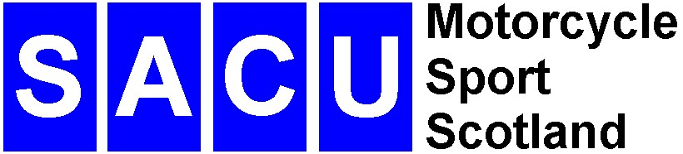
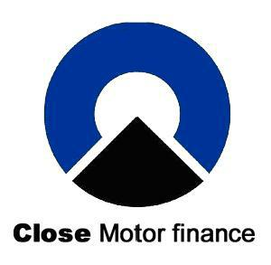
Close Motor Finance Sponsors SACU Scottish Enduro Championship 2010

Close Motor Finance Limited has agreed to become the headline sponsor for the Scottish Enduro Championship in 2010. The Championship will be known as the Close Motor Finance Scottish Enduro Championship and the season kicks off with the Melville Motor Club at Pathhead on the 24th and 25th April. Regulations can be downloaded at www.scottishenduros.co.uk www.melvillemc.co.uk www.enduronews.com

There are up to twelve rounds of the Scottish Enduro Championship each year from Elgin down to Dumfries. The events vary from sand to mud and rocks giving the Scottish rider many different experiences. Scotland has produced several top class international riders over the years who have gone on to compete at the highest level and there are a number of youngsters coming through who are shaping up very nicely right now.

Close Motor Finance has a long association with the motorcycle industry providing a Close and Personal service for customers.

‘The Scottish Enduro Championship has shown consistent growth over the years with increased professionalism and attention to safety for the competitors. Close Motor Finance is delighted to provide support for the Championship and we are looking to build upon this relationship in the future’, said Scottish branch manager Phil Wilson.

‘It is great to bring a major sponsor to the Scottish Enduro Championship and I am sure the riders will respond when upgrading their machinery to support this initiative’, said Charles Mackenzie chairman of the SACU Enduro Committee.

Close Motor Finance are specialists in motor finance and work to make sure their dealer’s customers drive away happy with the vehicle they want at a price they can afford. Each year they help countless people finance vehicles either new or used, whether it is a road bike, car, light commercial, motor home or caravan.

With the support of over 5,000 new and used dealers across the UK, they can process finance proposals on the spot so that customers buying a vehicle can drive away the same day with no hassle.

Close Motor Finance Limited are committed to delivering a local and personal service, working through a national branch network rather than call centres based miles away. They do not use a constraining credit scoring system and none of their decisions are made solely by an automated computer system; instead their skilled branch staff oversee all finance proposals.

Whether you are a private or a business customer, they can provide you with a tailored finance solution to suit your needs, as well as offering a range of insurance products to protect you and your investment.

Close Motor Finance is part of Close Brothers Limited, the UK’s largest independent merchant bank.

Please visit the Close Motor Finance Limited website or contact our local Scotland Branch for further details.

Address

Close Motor Finance
Fairbairn House
Fairbairn Place
Livingston
EH 54 6TN

Tel: (01506) 463443

www.closemotorfinance.co.uk

Charles Mackenzie
SACU Enduro Chairman
Tel: 0131 443 4275
www.scottishenduros.co.uk
e mail webmaster@scottishenduros.co.uk

