SACU ISDE Team – Finland – Kotka 2011

Wednesday 10th Aug 2011

Wednesday started with a dry run out for the riders – or so it seemed from the Parc Ferme. But heavy rain in very localised showers meant the riders arrived at the first service area cold and wet again.

With the riders posting some very fast test times on the Tuesday hopes were high today for a great run on new going. Only one lap of 230 kms with an early finish today. But this is the ISDE and it is not just about the tests it is about finishing.

Fraser Norrie notice his back wheel acting up before he went into the second test and stopped to look. Loose spokes and some even out of the nipples. In order to make sure he finished the event he stopped –repaired his wheel – losing 20 minutes on the day and then blasted round the rest of the course without losing any more time. He is still in the event and making up time in the tests – still 3 days to go.

Neil and Ricky had solid days today managing to stay on time and keep posting solid tests to move up again.

The very rocky first test was out on the first lap but back in again by the end. The final test from yesterday was dropped as delays occurred as they had to stop and clear the course.

Lee Edmondson is top GB Club rider in 12th, Neil is in 17th and Ricky in 22nd. Frasers 20 minutes penalty has pushed him back a bit.

The service crews performed their usual magnificent job with Kevin Gauld and Alastair Miller being joined by Campbell Chatham for the day.

The Flying squad carrying essential spares circulated around the service areas – but a wrong GPS position meant an interesting detour along some very narrow forest roads – to end up nowhere. So back to the start and await the riders.

Day 4 and 5 are the same route run twice with the riders doing 340 kms for the day.

Still going strong and three fit riders ( not sure about the dads who are getting more excited as the days go on).

Thanks to all the well wishers who are sending emails and Facebook messages – keep them coming

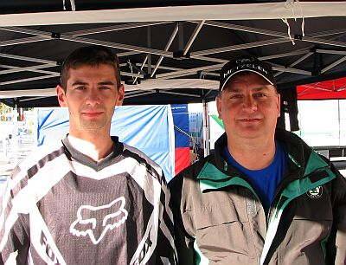

Neil and Campbell Day 3

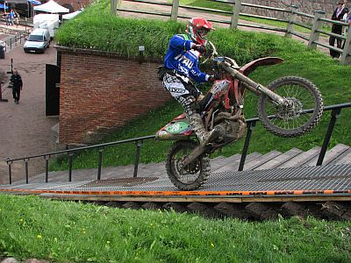

Italians at play leaving the Bastion

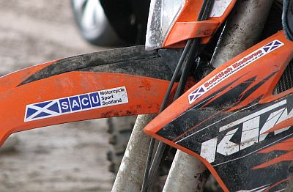

Flying the flag

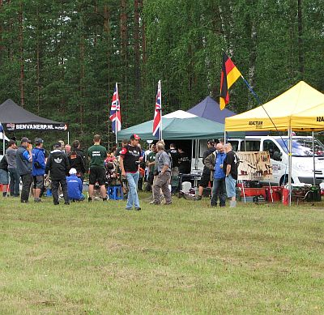

Onkamaa service area – we wait for Fraser

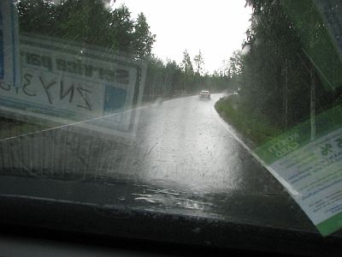

It was bad in the car – imagine being on a bike in this

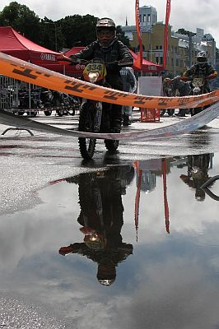

Ricky makes it to the final check on time

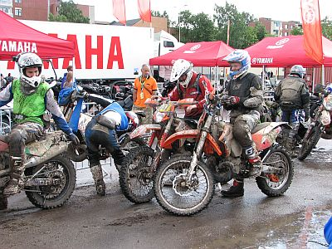

And Fraser makes the end of Day 3 – a real achievement

