SACU ISDE Team – Finland – Kotka 2011

Tuesday 9th Aug 2011

All riders safely home now after another exciting day. Following the same course as yesterday the riders knew what to expect but had a longer day as the time schedules were eased to avoid speeding through villages.

The day started in rain with the riders turning up at the first service check at Hamina Bastion frozen after a long road section in wet shirts. The weather then improved with sun and dust in the afternoon.

Again it was 300 kms covered at high speed with the wet trails also cut up by the bikes from the previous day.

Ricky had a small problem with a bog today which slowed him a bit but was still flying through the tests.

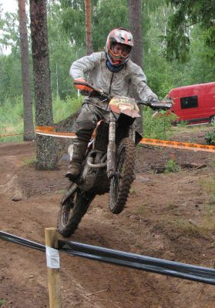
Neil had a flyer of a day and ended up 2nd in the GB rankings with Ricky in 4th and Fraser on the move up to 5th.

Overall the riders improved their classification in the club class with Neil now up to 19th, Ricky in 27th and Fraser up to 32nd.

The SACU team is now up to 7th club team only 3 minutes behind the leaders.

The support team again did a fantastic job as did the Dads – et al

A new course for Wednesday with new challenges – but as usual the Rocks of the 1st test have to be successfully negotiated.

Ricky flies in test 3

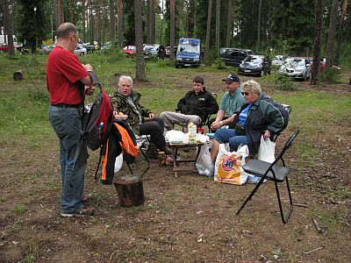

Brits abroad – it must be time for tea

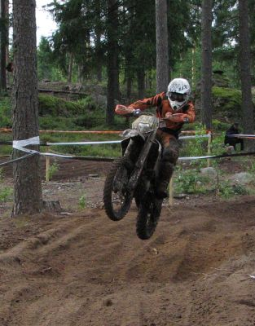
Neil gets some air on the way to a fast day

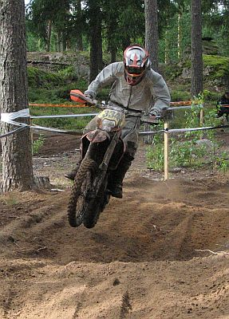

Ricky on the ball

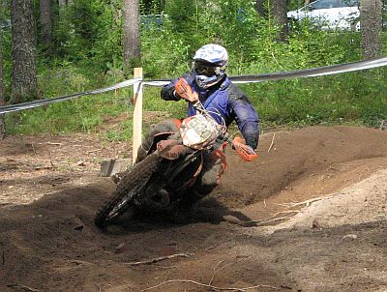

Fraser gets down to business

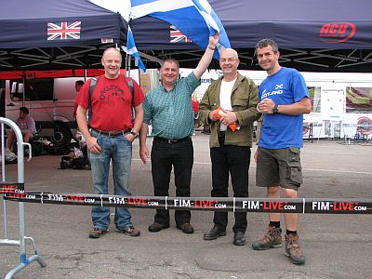

Sam and the Dads.

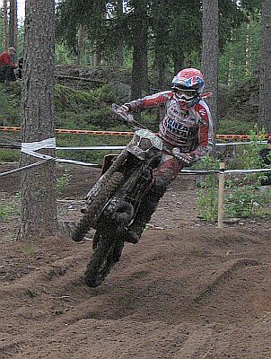

Team GB was flying too – Danny gets it on

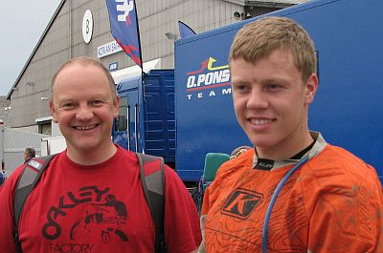
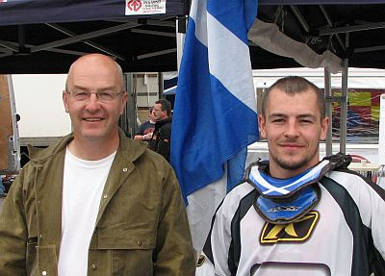
Kenny and Fraser Jim and Ricky

