SACU ISDE Team – Finland – Kotka 2011

Thursday 11th Aug 2011

Scots show true ISDE Spirt.

Leaving Kotka harbour in heavy rain was not a good omen for the day but Scottish spirts remain undampened.

Neil and Ricky started together and headed off into the rain. Neil had a problem with his spindle and did not get the new tire he was looking for. This proved a recurring problem as the spindle nut would not stay tight and eventually Neil replaced it. Running all day with a suspect rear end is not good for confidence but Neil still rode flat out and look very good in the Salpalinja test – the longest so far at 8 kms with a sandy quarry to start and finish. Riding in sand is a team strength and it showed in all the sandy tests.

Neil finished on time and is back out with the rear end sorted.

Ricky pushed hard all day but problems meant he dropped time despite some great test times again. Showing true grit as SACU team captain he pushed on to bring the bike home ready for the last day of full on going – a rerun of todays course – hopefully with better luck

Fraser finally got his bike home – but what a day. Showing amazing resilience and great maturity he managed to get his back round almost 2 laps with a failing rear shock. When word got through Sam managed to source a spare and the flying squad then had to come from the furthest past of the course to pick it up and drop it at the Bastion service area.

Fraser eventually turned up to the relief of his Dad – but was in great pain with a very sore back. The cause quickly became obvious when he swapped the shock. See the attached pic. It came out of the bike in several pieces – how on earth Fraser managed to ride it is a miracle – just showing the determination of this young man at only 19.

With the new shock fitted – but a shorter one so some work needed on the forks for tomorrow he headed off back for the final test at the Ski Slope with a long cross country before the Parc Ferme. Yet still managed 26th in the test – just behind Neil.

The hardest day yet for all the riders as the ISDE really starts to bite – if it was not for bad luck we would have no luck at all. Congratulations to them all for showing great resolve

The overall placings changed due to all the problems the riders encountered today – Neil ended up 2nd top Brit in the Club teams behind Lee Edmondson.

Neil -16th Fraser 41st Fraser 81^{s}
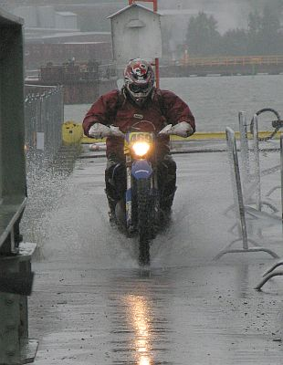

Wet start to the day

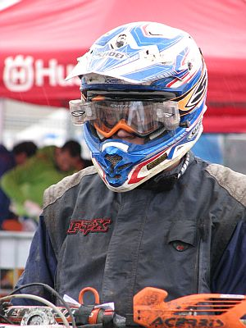

Fraser contemplates the day ahead

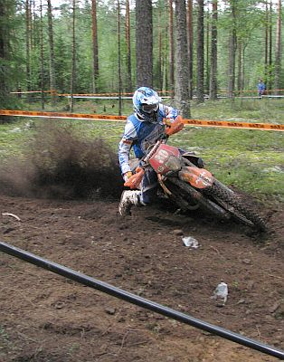

Top rider Eero Remes gets on the gas

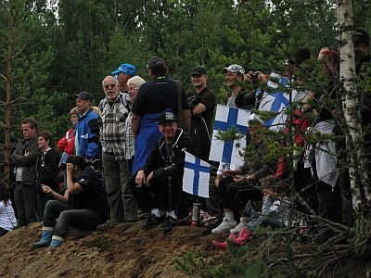 The Finns support their home riders

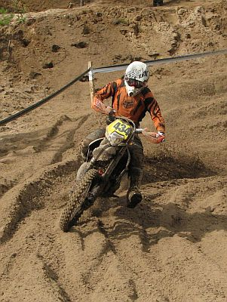

Neil at home in the sand

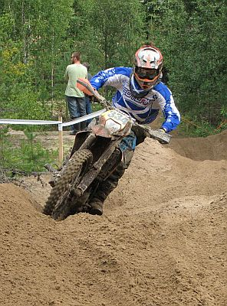

Ricky gets a move on in the test

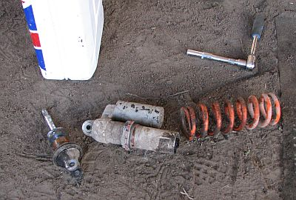

Could you ride one of the toughest events in the Enduro world on this – well Fraser did.

