SACU ISDE Team – Finland – Kotka 2011

Saturday 13th Aug 2011

3 riders started at Kotka Harbour on Monday and after a week of trials and tribulations Scotland has 3 riders with our best ever ISDE finish. A tribute to the riding ability of the team (which was never in doubt) but their resilience in spite of massive obstacles to overcome proves that sending a young team was the right move.

Neil has finished the week on Gold – Ricky on Silver and Frazer may also be on silver – but to be confirmed. To have all our riders safe is a great relief for all the helpers and Dads out here and I am sure the whole Scottish Enduro community is proud of what they have achieved.

If finishing was not enough Ricky Mair dominated his hot E1 heat and lead from start to finish – including a massive whip over the finish line – see pic below.

Neil put in a solid mid pack race to preserve his bike which was sounding a bit off – and he couldn’t risk not finishing after all his effort this week. But still raced and got some big air.

Frazer had a problem and ended up starting dead last – with a fantastic charge right through the pack to 6th at one point. He raced right to the end – even passing another rider in mid air over the finish flag.

Frazer had massive problems on Thursday with his shock failing completely – but he has been rewarded with a great finish. Tough is not the word for this rider – and still only 19.

It has been a week of highs and lows but all the riders came through it and are very keen to have a go again. Scotland should be proud.

A big thank you to all the British support team – from John Collins and Ted Bartlett for handling the politics of the sport , Dave May Millar and Dusty for organising a fantastic support effort and to all the crews who looked after the riders every day. The support the riders get is a major part of the success of the event – and Team GB does it very well.

In the Team event the Husaberg Czech team won overall, Wales were the best British Club team and Scotland finished in a fantastic 9th place – top 10 in the world.

Overall Results

Neil was 2nd top Brit Team rider in 15th place (Lee Edmondson was in 6th.
Ricky finished up a few places in 35th after his heat win
Frazer finished the week in 72 – not a reflection of his riding but an achievement considering the problems he overcame.

Thanks also to Sam Davidson for his long efforts to ensure the team entered and was prepared. His experience is invaluable and keeps to riders on track. And a thank you to Kevin (the coolest guy in the paddock) for manning a check every day with the help of Alastair Millar.

And congratulations to the three Dads Campbell, Kenny and Jim – it’s been a long haul but the boys done good.

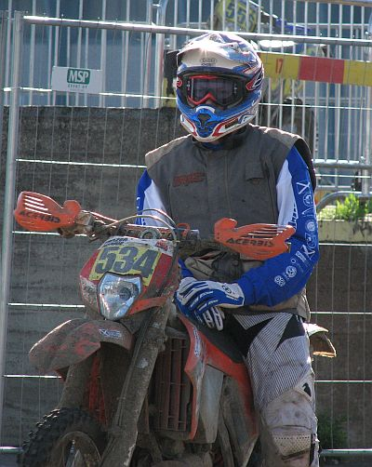
Frazer contemplates the final day after a tough week

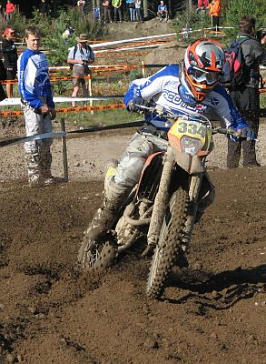

Frazer looks on as Ricky leads the way

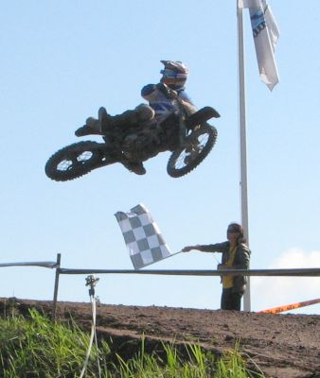

Ricky celebrates his race win and finish to the 6 days

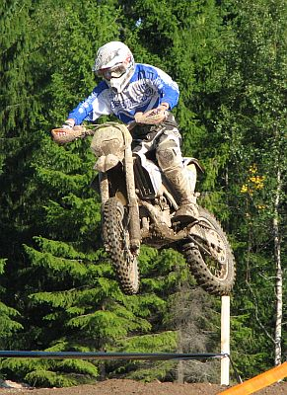

Neil gets some air on his way to Gold

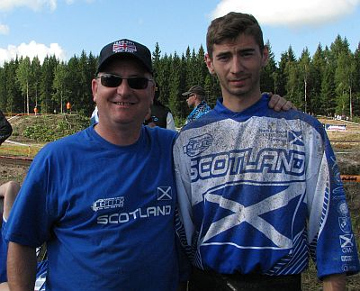

29 years since a Chatham was last at an ISDE – worth the wait

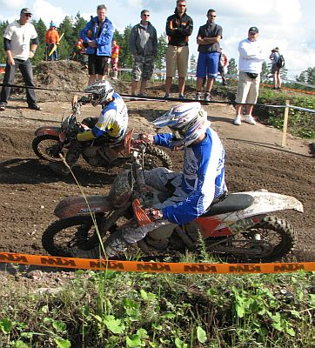

Frazer passes another rider as he makes up places.

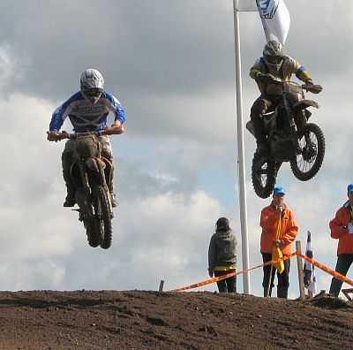

Frazer flies over the finish of an ISDE he will never forget.

