SACU ISDE Team – Finland – Kotka 2011

The Prologue

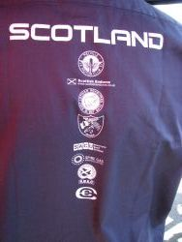
Finland – land of lakes and forests – and rocks – lots of them and really big. The first impression of Finland is of a flat landscape with lots of trees and solid rock. Driving from Tampere via Helsinki to Kotka on the Russian border there were no real hills to be seen on the trip – but the road cuttings showed solid rock under everything.

Very much like the country round Lossiemouth so the Scots should feel right at home. But – did I mention rocks already – lots and some the size of houses. With the very first test starting with rocks it would be easy to go out on the first day with a crushed exhaust or derailed chain – so caution to start with.

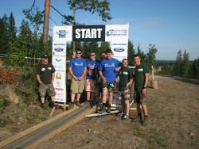
The team arrived last Monday with Sam immediately getting them out on the tests to get a feel for the country. They had a week to prepare and by the opening ceremony on Saturday were just raring to get going.

The TeamGB pits area is well set up on the docks at Kotka – with all the teams together in one paddock. A big step forward was getting all the bikes brought over by the Army in big trucks – 2 ferry crossings and a long journey – but all the bikes arrived safe.

With Sam supervising operations the Scottish team got their 3 KTM’s ready to go – a quick blast round the wee test track (3 corners) to test sag and jetting and they were good to go. Then sign on and scrutineering – no problems there. But Finland has a “lights on” policy so the bikes must keep their lights running all week or Polis will stop them.

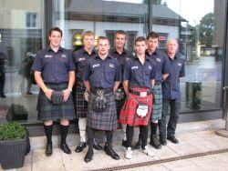Once the bikes were in the Parc Ferme it was time to relax – with a night club next door the GB team got well settled in.

The Opening Ceremony was held at Hamina Bastion – an old bomb proof armoury and a large open air tented venue.

The teams lined up and were lead down the stairs by Paul Eddy carrying the British flag. Scotland followed looking every inch the team in their Scotland shirts and kilts. The most distinctive team there.

The new ISDE flag was unveiled – the first time there has been a flag since it’s formation in 1913 (as the ISDT).

Then the ISDE was declared open.

Now just one day to wait with Ricky of at 9.06 on Monday followed by Neil at 9.27 and Fraser at 9.48. With about 8 hours and 300 k’s of riding in front of them.

Best of luck lads – and stay safe.
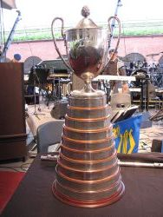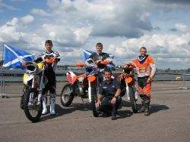
The Trophy – 98 years worth The Riders

