SACU ISDE Team – Finland – Kotka 2011

Monday 8th August 2011

Well of course it was too good to last – rain overnight – just enough to soak the ground and keep the dust down. The riders set off to grey skies for a day of 300 kms of very fast tracks and 8 special tests.

Ricky Mair was first off on the road – followed by Neil Chatham and then Fraser Norrie. The arrows are a faint pint and grey colour – not the easiest to see but the riders managed to get round and stayed clean all day –a major achievement.

The first test was a real bike breaker with loose rocks then large boulders designed to smash exhausts and people alike. One of the GB team ended up with a nicely dented rim – great for the rest of the week. Luckily all the Scots got through in one piece. But Ricky Mair said “I went in like Cervantes and came out like Mary Poppins!”

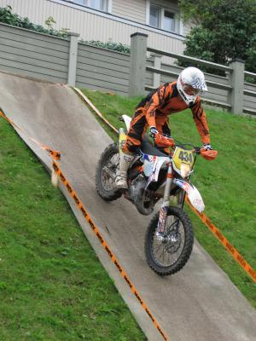
It was then on to Hamina Bastion – the first service check and a quick go over the bike with the GB Support crew ready for them. Dropping down a steep bank on carpet proved interesting – with riders wondering how to get back out. There was a steep metal ramp which proved no problem with Fraser getting some freestyle out of the arena.

Then very fast tracks through the flat forests but always tricky. Ricky got stuck in what he called the worst bog he had ever seen (and he has been to Griffin!) – basically a large drainage ditch bit the worse for wear once 600 bikes had been through it. Neil also got stuck but pushed on out.

The preride report said it was a big trail ride with tests – but the tight times, overnight rain and large number of riders turned it into a real test of man and machine.

The riders also had to negotiate a great sandy MX test – very much like Woodside – at high speed. The furthest test of the day was straight out of Lossie – sand, trees, whoops and some very deep ruts. Every rider fell at least once but still managed very good times for the day.

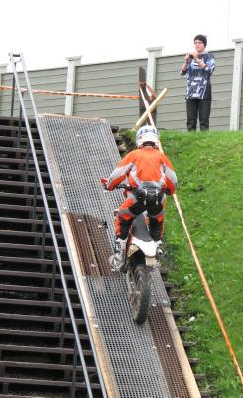
Fraser caught up some riders in the test and had a bit of a traffic jam as he started late in the day – but his performance should put him further up the start list in the morning.

Star of the day was Allyn Scotland who recovered Ricky’s tool bag which slipped off in a test.

Finishing off at the pits with the 10 minute work period – each rider successfully changed a rear tire and had a quick look over the bike. All ready for Tuesday.

Overall Ricky 23rd Club Rider, Neil 25th and Fraser 40th. 1st, 2nd and 5th GB club riders. A great start – but a long way still too go.

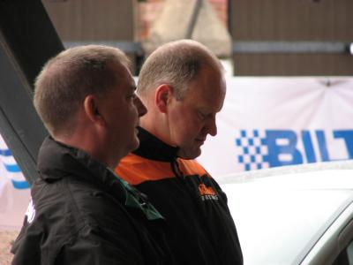

The Dads – waiting is the hardest

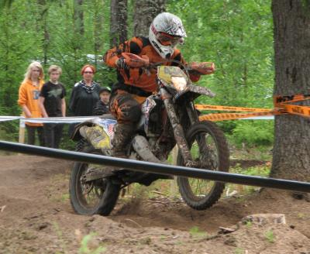

Neil flying in the test
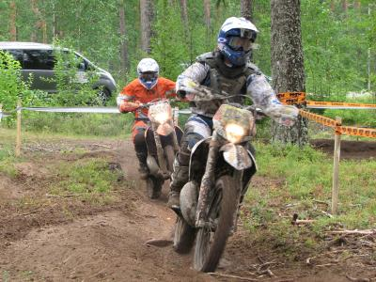

Fraser catches up with traffic
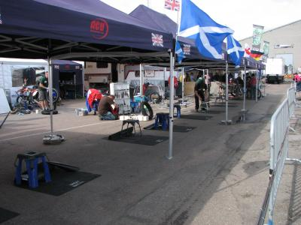
The Pits – well run by Sam .
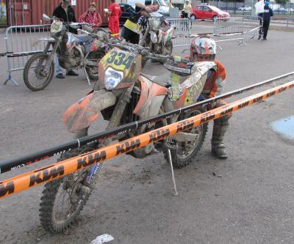

Ricky gets a few adjustments in before the work area

