SACU ISDE Team – Finland – Kotka 2011

Friday 12th Aug 2011

All three riders still going and giving it everything.

After the tension of yesterday it was a more relaxed team that took to the track today. Sore and very tired the team set off to try and improve their placings but most importantly to preserve their bikes for the final day MX.

The first test was cancelled today – no Ski Slope as it had cut up very badly and was proving a real problem for some of the riders. So any easy road ride to the start of the main offroad loop.

Frazer ( with a Z) still has a sore back but having a working shock meant a much easier ride for the day. With no major issues today it was time to impress in the tests and he was flying. Watching him take to the air in the final Sand Quarry test was impressive. His shock is not setup fully yet but it did not seem to slow him down much. A fall in the test cost time – but he still manged 20th overall Club Team rider. Hopefully he will have a clear run in the final MX on Saturday

Arriving back at the Parc Ferme he looked tired but relaxed after a very exhausting week so far.

Ricky Mair had some work to do down in the Parc Ferme with his clutch – but all sorted he blasted round the course and kept on time. Showing no problems he quickly caught up and passed numerous slower riders. (See attached Pic)

His four stroke KTM has proved reliable apart from a clutch problem – but that alone dropped him down the ramkings. In the ISDE you have to keep going – and Ricky and the team have done that in spades. His final test result of 6th in the Club class showed just how fast he was going.

Neil had another steady day today – but of course there were some problems. Leaking forks were quickly cleaned out and back to normal – just one of the numerous on course repairs Neil has had to do this week. His 10th in the last test showed his experience in sand as it was a large sand quarry.

Neil is currently top Scot in 16th Overall in the Club team class. Very impressive at his first attempt

Overall Placings – Neil 16th, Ricky 37th, Fraser 72nd.

A fantastic job to keep going through a very extreme week the riders have showed real grit and have a chance to really shine tomorrow (and hopefully have some fun) in the final MX.

The Flying squad can honestly say they know what the riders went through as the road we used (by SatNav) was actually part of the course. What look like dirt tracks or forest roads are actually roads with speed limits (60Kms) – so driver Kenny was a wee bit concerned that we may meet a full on rider coming the other way – luckily they had all passed. The car did very well in the whoops and berms.

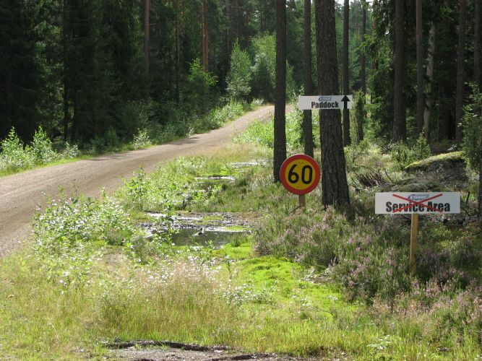

Forest road – with a speed limit !!

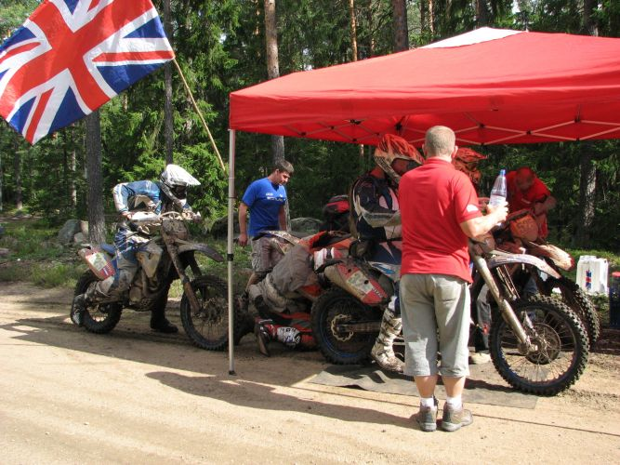
Frazer checks the bike over at a Forest check

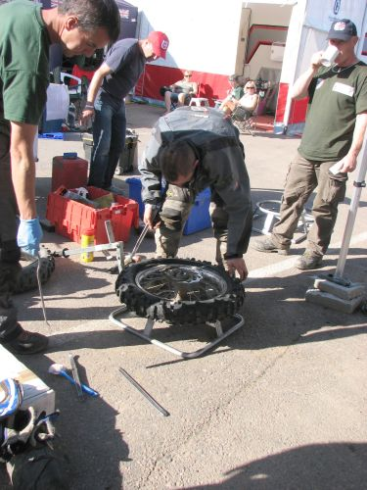
Ricky gets a final tire change in for tomorrow

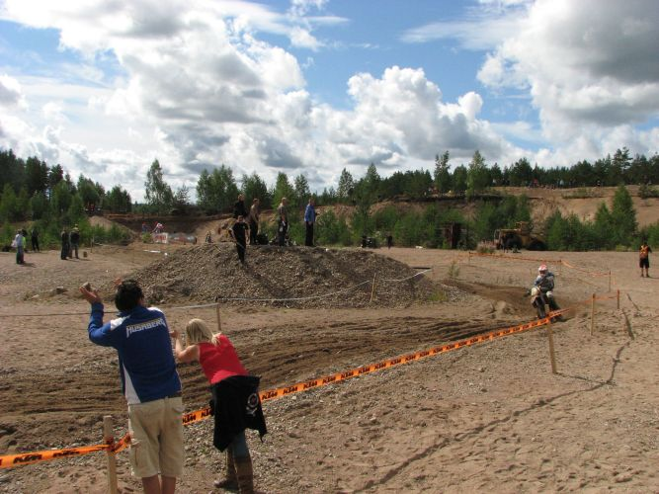
The Sand Quarry test

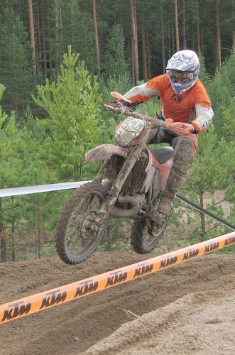
Fraser flying in the test

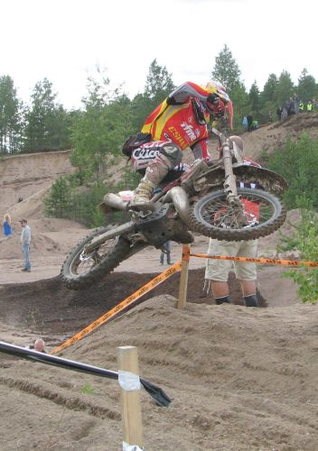
World class Spanish rider gets a whip in

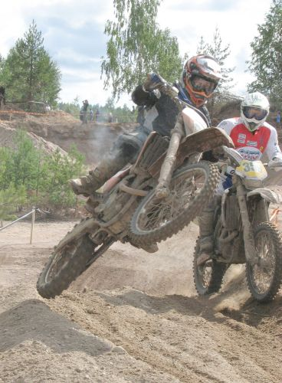
Ricky passes a rider in the test – in mid air – check his expression !!

