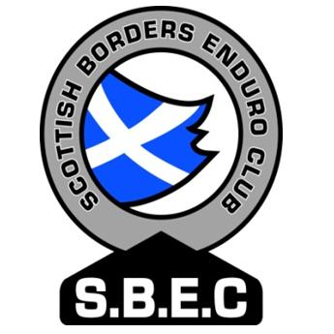
Scottish Borders Enduro Club
(SBEC MCC Ltd)

Affiliated to the Scottish Auto-Cycle Union

MEMBERSHIP APPLICATION FORM 2014

Memberships are valid from 1st. January to 31st. December.

Name : ___________________________________________________________________________________

Address : ___________________________________________________________________________________

___________________________________________________________________________________

_______________________________________________________ Postcode: ________________

Telephone : ___________________________________________________________________________________

Mobile No : ___________________________________________________________________________________

E-mail : ___________________________________________________________________________________

Date of Birth : _______________________________________ (especially if under 16yrs)

Membership : Adult Rider £15
School person £10 (Under 16 yrs – Youth Licence forms only)
Associate £ 7 (Non-rider)

Do you require a Competition Licence? Yes No (Please note that SACU Licence
Application forms can only be
sent to Scottish addresses.)

Do you compete in? H&H Enduro Trials Moto X

Which class will you compete in this year?

SBEC MCC Limited is a company limited by guarantee and incorporated in Scotland with registered number 363350 having its registered office at Upper Flat, Dandswall, 10 Shawpark Road, Selkirk, TD7 4EE . By completing this membership application I agree to be a member of SBEC MCC Limited, and to be bound by the Articles of Association of SBEC MCC Limited.

By completing this form you agree that SBEC MCC Limited may process your personal information and provide it to any regulatory body (e.g. the SACU or ACU) for the purposes of your membership and your participation in motorcycle sport.

Signed: ________________________________________________________ Date: ____________

Signed: ________________________________________________________ Date: ____________
Parent or guardian if under 16

Please return completed form and fee(s) to: Peter Nixon (SBEC) (Please make cheques
Old Prieston payable to: SBEC MCC Ltd)
St Boswells
Melrose
TD6 9HQ

E-mail : sbec@clan-ross.co.uk
……………………………………………………………………………………………………………………

Official Use Only:

Date Received: _____________ Cheque No: __________ Member No: ______

