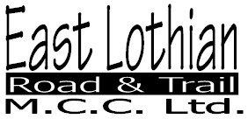
Affiliated to the Scottish Auto Cycle Union

Membership Application Form
Please complete and return to the Secretary

Caroline Thomson

40 Gallowhill Road

Kirkintilloch
G66 4AJ
e-mail : carolinethomsonlxii@gmail.com

Name

Address

Tel .

Mobile No.

E-mail

Are you willing to assist in the running of club events ? YES NO

Do you compete in : - Enduros / Hare & Hound Moto X Trials

Do you require a competition licence ? YES NO

I wish to apply for : -

Full Membership £16
Schoolperson £10

I understand that the club is not liable for any injury or damage to persons or property. I hereby apply and consent to become a member of East Lothian Road and Trail Motorcycle Club Limited (the "Company" subject to the Memorandum and Articles of the Company. I acknowledge that as a member of the Company, in the event of the Company being wound up within one year thereafter I may be liable to contribute to the assets of the Company an amount not exceeding One Pound Sterling (£1.00).

Signed Date

Signed Date
Parent or guardian if under 16

