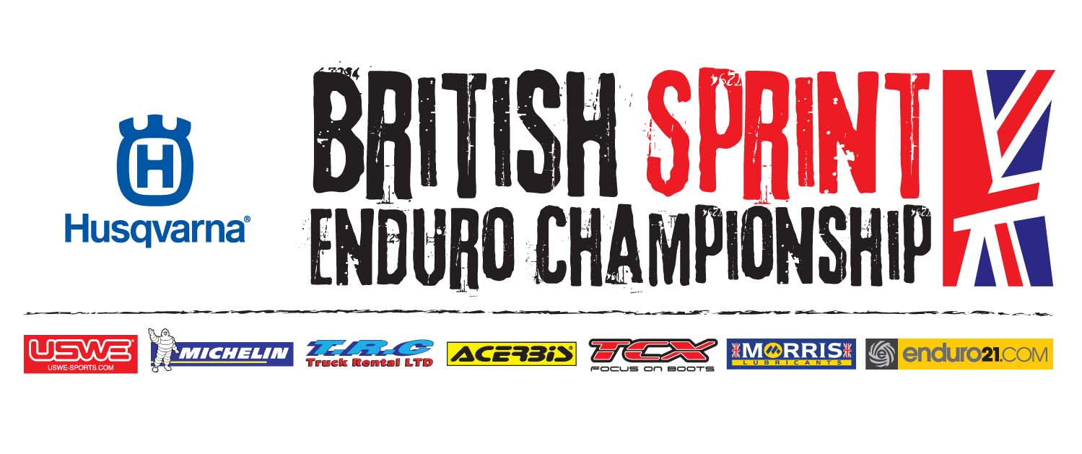For immediate release: 4.4.2013
Preview – 2013 Husqvarna ACU British Sprint Enduro Championship, Rnds 1&2
Eagerly awaited 2013 BSEC series kicks off at Chavenage Farm, Gloucester.
It’s all systems go for the 2013 Husqvarna ACU British Sprint Enduro Championship, which kicks off this weekend at the picturesque Chavenage Farm venue in Gloucestershire…
Attracting an impressive line-up of national and international talent, the Elite class is once again hotly contested. As the defending champion, Electraction TM’s Jordan Rose will lead the charge at Chavenage but with a stacked entry he’ll face a tough title fight if he wishes to retain his #1 status.

Following his sensational double win at the final rounds of the 2012 BSEC series at Canada Heights, Finland’s Matti Seistola (Husqvarna) joins the championship as one of the leading favourites for Elite class glory. Seistola, who will be supported by Freestyle Husqvarna, currently sits third overall in the Enduro 1 World Championship standings and will be keen to use that momentum to ensure a winning start to his BSEC campaign.

Committing to the 2013 series, former champion Tom Sagar (Colwyn Bay KTM UK) will be a formidable opponent to both Rose and Seistola – not only at Chavenage Farm but throughout the series. Fresh from his dominant victory at the opening round of the British Enduro Championship in Scotland, Sagar is hungry to win this weekend.

As the 2012 series runner-up, former MXGP rider, Tom Church (Husaberg) was one of last year’s standout performers. Improving in both speed and experience, Church quickly became a regular podium contender. Now with a full season of competition behind him and partnered with Midwest Husaberg, Church has his sights set on reaching the top step of the podium in 2013.

After a slow start to his 2012 season, Crescent KTM’s Darryl Bolter came on strong as the series passed the halfway point. Eager to make a stronger start to his new season, expect Bolter to come out fighting for a podium result this weekend.

Add in a whole host of British talent including the Edmondson Racing Honda duo of Jamie Lewis and Lee Edmondson, Mark Roberts (Electraction TM), Ryan Voase (Kawasaki), Scotland’s Ricky Mair (KTM) and not forgetting Elite class rookie Jamie McCanney (Husaberg) – the current leader of the Enduro Youth Cup World Championship – the stage is set for a thrilling start to the BSEC season.

In the Under 23 category, MPS Racing Husqvarna’s Jack Rowland enters Chavenage Farm as firm favourite for top honours. The 2012 European Enduro Champion was forced to play second fiddle to last season’s leading trio of Danny McCanney, Jonny Walker and Alex Rockwell. But with those three moving on, Rowland is more determined than ever to establish himself as the champion elect.

After a 100 per cent winning record in the Under 19 category in 2012, Crescent KTM’s Steve Holcombe moves into the U23 class for 2013 but is unable to cmpete this weekend due to a recent shoulder injury. Runner-up to Holcombe in 2012, TM’s James Dent also switches to the U23 class for 2013 and will be keen to establish himself as a serious podium contender. Add in Scotland’s Frazer Flockhart (KTM) and Frazier Norrie (KTM), Husaberg’s Aaron Smith, Max Varney (Yamaha) and Andrew Noakley (KTM) and the battle for a top five result with be as fierce as ever.

Ending the 2012 season third overall in the Under 19 class, MPS Racing’s Robert Johnson has his sights set on winning this year. Fast and extremely consistent, the Husqvarna rider is solely focused on winning this weekend. But with CTR TM’s Josh Gotts and Kawasaki’s Joe Wootton, along with Scott Altass (KTM), Luke Flack (KTM) and Luke Gorse (KTM) all in the mix, winning won’t come easy.

As the defending champion, Brad Freeman (KTM) leads the charge of the 125 Youth Cup riders. Claiming four victories in 2012, Freeman will be keen to add to that tally in 2013, though Jon Hunt (Husqvarna), Lee Sealey (Husaberg), Jordan Ridgway (KTM) and Charlie Frost (KTM) all have their sights set on podium results.

As one of the largest classes of 2013, the Expert category is also one of the toughest to predict. Can the 2012 champion Richard Ely (KTM) get his season off to a winning start or will Tyson Maytom Jones (Husaberg), Brad King (Kawasaki), Steve Hunt (KTM), Dan Beaven (KTM), Gethin Francombe (TM), Jamie Paget (Husaberg) or Jack Lee (Gas Gas) beat him to it?
Securing a maximum of 10 wins from 10 starts, Jane Daniels (Midwest Husaberg) dominated the Women’s class in 2012. But forced to start her title defence with a recent injury, Katie Walker (KTM), Hanna Styles (Husaberg) and Liz Childerley (Husaberg) are hoping to capitalise on Daniel’s misfortune and take a surprise win.
With a bumper entry list of riders plus additional two new classes for 2013 – Expert Veterans and Clubman Veterans – along with the strongly supported Clubman class, the opening rounds of the 2013 Husqvarna ACU British Sprint Enduro Championship are set for an explosive start in Chavenage Farm, Gloucester.
Spectator Info
Directions: The start area will be sign posted off the A46 Bath Road. Chavenage farm, Tetbury, Gloucestershire. Postcode: GL8 8XU
Entry Fee:
Adults £10.00 each. Under 14 year olds free. Overnight camping £10.00
Parking:
Vehicles will be parked on a generous, flat parking area joining onto the rider’s paddock and start/finish area.
General info:
Racing starts at 10.00am both days. A sighting lap (starts 9.00am) and four timed laps will take place during the morning session before a 30-minute break and paddock autograph signing session. A three-lap afternoon session will then take place. On Sunday the event will end with a prize giving ceremony.
Husqvarna British Sprint Enduro Championship 2013
Rnds 1&2 - April 6/7 Chavenage Farm, Gloucester
Rnd 3 - May 26 Saints Well, Mid Wales
Rnds 4/5 - July 6/7 Llangrove, near Monmouth
Rnd 6 - August 4 Westwood, near Sheffield
Rnds 7&8 - August 31/Sept 1 Chacombe, near Banbury
www.enduro-sprint.com
About the BSEC
The Husqvarna British Sprint Enduro Championship is the UK’s newest off-road motorcycle race series, promoted and organised exclusively by GMC Events Ltd. Enduro is one of the world’s longest standing off-road motorcycle disciplines, the motorcycle equivalent of car rallying. Sprint enduro is an exciting new rider, spectator, and media friendly discipline that delivers simple to understand, day-long, enduro racing action. The series caters for the best enduro talent in the UK.
About Husqvarna
Husqvarna is an iconic off-road motorcycle brand. Enjoying competitive success at the highest level, in 2011 Husqvarna clinched the Enduro 1 and Enduro 2 World Championship titles with their TE250 and TE310 machines ridden by Finn Juha Salminen and Frenchman Antoine Meo. Building its first motorcycle in 1903 Husqvarna motorcycles were produced in Sweden until ’86 when the company was sold to the Cagiva Group, which later became MV Agusta S.p.A. Enduro greats such as Anders Eriksson, Paul Edmondson, Samuli Aro, Stefan Merriman, Petri Silvan, Antoine Meo and Juha Salminen have all enjoyed world championship winning success with Husqvarna. http://www.husqvarna-motorcycles.co.uk

