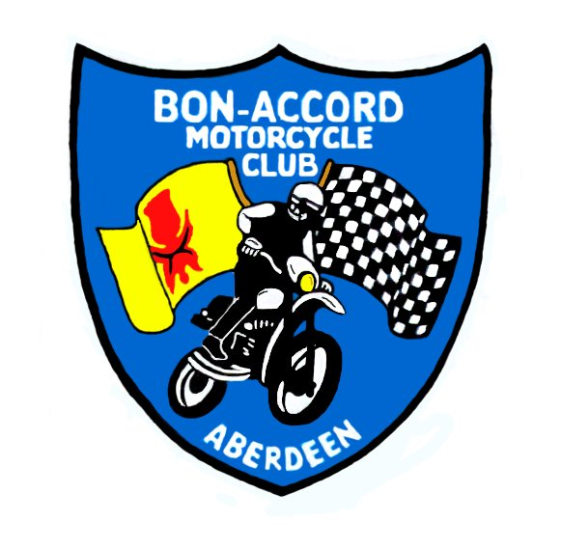

Bon-Accord Motorcycle Club Ltd

12 HOURS HARE & HOUNDS

Tinto Park, Rigside, South Lanarkshire
Sunday 24th June 2012
SACU Permit No: 12045

Sign-on and scrutineering 3pm-8pm on Saturday 23th June.
By prior arrangement sign-on and scrutineering on Sunday 24th June starts 6.30 am.

Sunday race duration 8am to 8pm

Supplementary Regulations

Organised under the rules of the SACU and the Standing Regulations of the ACU for Hare and Hounds events, together with these Supplementary Regulations.

Eligibility
Open to any type of off-road machine, Adult solos only - Expert, Over 40’s, Clubman and Sportsman.
Riders aged 16 & 17 must have their entry accompanied by a signed Parental Agreement Form.

Iron Man Classes Iron man one bike per rider
Expert, O/40, Clubman, Sportsman

Team Classes Teams one bike per rider or shared
Expert – 2 riders
O/40 – minimum 2 riders, maximum 3 riders
Clubman – minimum 2 riders, maximum 3 riders
Sportsman – minimum 2 riders, maximum 4 riders

Closing Date
Entries close Wednesday20th June. Please send with your entry at least one stamped self addressed envelope for your rider number, if you wish a copy of the results as well, then please send two.

Venue
Tinto Park is located off the B7055 Rigside to Winston road South Lanarkshire. About 3 miles off the M74.
(see enclosed map)

Signing On
Commence Saturday 23th June at 3pm and Sunday 24th June 6.30am.
Competition licences must be shown.

Scrutineering
Scrutineering will be carried out under SACU Hare & Hound Regulations. Riders are to present themselves to the
scrutineers with helmet, dog tags, boots, gloves and their machine. All machines must be scrupulously clean.

Race Start
Machines should be brought to the starting line 15 minutes before the start time.
All races start with dead engines – Le Mans type start will be at the discretion of officials on the day.
Iron men start first followed by Team classes with experts first.

Race Duration
12 hours. Ties will be decided upon number of laps completed and riders on the same lap will be placed in order in which they took the chequered flag.

Lap Scoring
BAMCC will supply each entrant with a RFID transponder tag for this event. The tag will be attached during scrutineering in a location on the bike determined by the scrutineer (Normally on a plastic part at the front of the bike).The tag must remain attached to the bike for the entire duration of the event. All classes will go through the same scoring gate. Riders must take the chequered flag at the end or they will be classed as non-finishers.

Environmental
No goggle Tear Offs allowed in Hare and Hound events. See 2012 Standing Regs. Riders may use Roll Offs- but must collect damaged roll offs to prevent injury to livestock.

Refuelling/Repairs
Refuelling and repairs are only permitted in the designated Pits/ Refuelling Area.
Bikes only to be worked on in parc ferme’
Every competitor should have a fire extinguisher adjacent to his fuel.
Engines must be stopped while refuelling - environmental mat should be used while machine is at standstill & fuelling. Only riders, officials and 2 authorised helpers per rider are allowed in the pits & refuelling area.
Any machine that leaves the course or pits area will be deemed to have retired.

Exclusion penalties

Smoking in Refuelling Area
Refuelling with engine running
Refuelling other than in Refuelling Area
Course cutting or riding in opposite direction to the course
Outside assistance except when Refuelling
Excessive speed in Lap Scoring Area.

Results
They will be posted on www.bamccc.co.uk and www.scottishenduros.co.uk and mailed to all competitors who have supplied a stamped SAE.

Protests must be presented to the Secretary within 24 hours of the publication of the results.

Officials
Clerk of Course: TBA
SACU Steward: K. Gauld
Chief Scrutineer: TBA
Secretary of meeting: Di Stuart, 3 Woodview Place, Stonehaven, AB39 2TD

Preferred Rider No:
If you have a number on your bike and would like to keep it just put a note on your entry and I will try to give it to you if possible.

The Bon Accord Motorcycle Club Ltd.
A Membership form is enclosed with your entry in case you would like to join our Club. Membership is £15 and will expire 12 months from date of joining.

Basic Rules of a Hare & Hounds
- Go through the lap scoring gate.
- Go through slowly so your number can be recorded.
- Take the chequered flag to finish the race.

The Course
The course will be forestry going, part moorland and motocross track.

First Aid Cover
There will be Paramedics in attendance.

Awards
Iron man Classes – First, second and third place awards in all classes
Team Classes - First, second and third place team awards in all classes.
All finishers will receive a finisher’s award.

