

Bon-Accord Motorcycle Club Ltd

SACU SOLO CHAMPIONSHIP: HARE & HOUNDS

Glen Trusta Estate
Fern, Brechin, Angus
DD9 7RS

Sunday 13th March 2011
SACU Permit No: 11005
.
Scrutineering Starts 9:00am
.
Race Starts 11:00am

Supplementary Regulations

Organised under the rules of the SACU and the Standing Regulations of the ACU for Hare and Hounds events, together with these Supplementary Regulations.

Eligibility
Open to any type of off-road machine, Adult solos only. (Expert), (Over 40’s),(Clubman),(Clubman B) and (Sportsman). Riders aged 16 & 17 must have their entry accompanied by a signed Parental Agreement Form.

Closing Date
Entries close Wednesday 9th March. Please send with your entry at least one stamped self addressed envelope for your rider number, but if you wish a copy of the results as well, then please send two.

Venue
Glen Trusta Estate.This will be sign posted from the A90 Dundee to Aberdeen dual carriage way about 5 miles south of Brechin. (Opposite Bervie Chipper) Take the turn off heading for Menmuir and follow the orange arrows about 6 miles inland. (see enclosed map)
Please note the road in to the estate is narrow with passing places. Please show courtesy to other road users on the drive in to the start area.
The estate owner will allow overnight parking and has requested all generators to be off by 11:00PM.
Strictly no bikes to be started before 8:30AM Sunday morning.
Please respect these wishes as this is a new venue with great potential for future events.

Signing On
Commence at 9am. Competition licences must be shown. NOTE NO ONE EVENT LICENCES

Scrutineering
Scrutineering will be carried out under SACU Hare & Hound Regulations. Riders are to present themselves to the
scrutineers with helmet, dog tags, boots, gloves and their machine. All machines must be scrupulously clean.

Race Start
Machines should be brought to the starting line 15 minutes before the start time.
All races start with dead engines – Le Mans type start will be at the discretion of officials on the day. Experts first away then over 40s and so on.

Race Duration
Solos – 3 hours. Ties will be decided upon number of laps completed and riders on the same lap will be placed in order in which they took the chequered flag.

Lap Scoring
All classes will go through the same lap scoring gate. Every competitor must ride at walking pace through this gate, to enable the lap scorer to take their number. Riders must take the chequered flag at the end or they will be classed as non-finishers.

Results
They will be posted on www.bamccc.co.uk and www.scottishenduros.co.uk and mailed to all competitors who have supplied a stamped SAE.

Awards
In each class at championship rounds the first 15 finishers shall be awarded points at the rate of 20,17,15,13,11,10 down to 1.

Refuelling/Repairs
Can only allowed in the designated PITS/REFUELLING area. Every competitor should have a fire extinguisher adjacent to his fuel. Engines must be stopped while refuelling - environmental mat should be used while machine is at standstill & fuelling. Only riders, officials and 2 authorised helpers per rider are allowed in the pits & refuelling area.
ANY MACHINE/RIDER WHO LEAVES THE COURSE OR PITS AREA WILL BE DEEMED TO HAVE RETIRED.

Exclusion penalties

Smoking in Refuelling Area
Refuelling with engine running
Refuelling other than in Refuelling Area
Course cutting or riding in opposite direction to the course
Outside assistance except in Refuelling Area
Changing Machine during event
Excessive speed in Lap Scoring Area.

Protests must be presented to the Secretary within 24 hours of the publication of the results.

Officials
Clerk of Course: Ken Whittaker
SACU Steward: Charlie McKenzie
Chief Scrutineer: Robert Prodger
Secretary of meeting: Di Stuart, 3 Woodview Place, Stonehaven, AB39 2TD

Preferred Rider No:
If you have a number on your bike and would like to keep it just put a note on your entry and I will try to give it to you if possible.

The Bon Accord Motorcycle Club Ltd.
A Membership form is enclosed with your entry in case you would like to join our Club. Membership is £15 and will expire 12 months from date of joining.

Basic Rules of a Hare & Hounds
- Go through the lap scoring gate.
- Go through slowly so your number can be recorded.
- Take the chequered flag to finish the race.

The Course
The course will be forestry going and part moorland.

First Aid Cover
We shall have Paramedics in attendance.

2

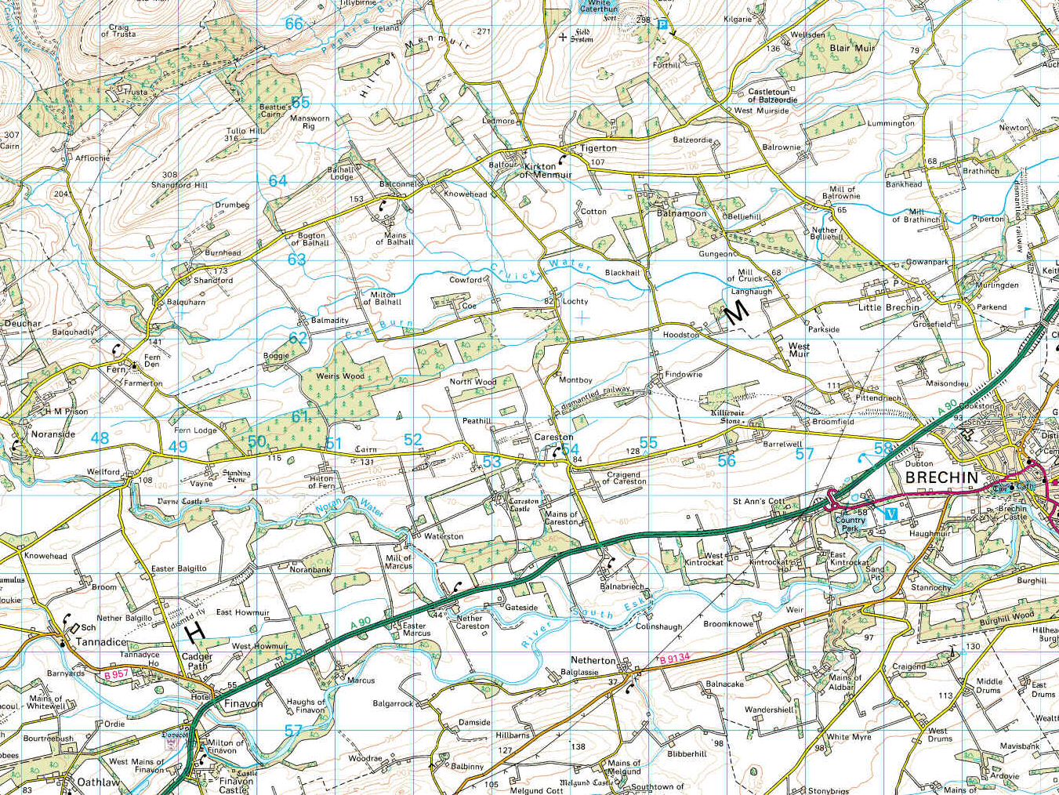

Entrance to Trusta Estate

3

