First Round to Murray Thomson at Metzeler Melville Hare and Hound 8th Feb 2009

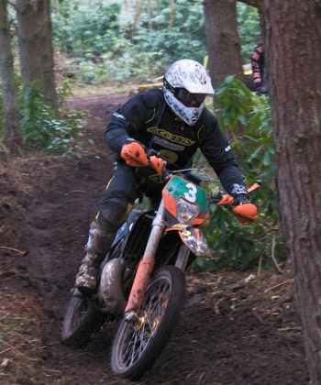
D3 Racings’ Murray Thomson won a very icy Metzeler Melville Hare and Hound on Sunday. Lochhouses farm saw 145 riders brave the conditions, although the forecast was for worse, the ground was hard on the motocross track and much better through the trees. Following a 500 mile round trip for parts from Paul Edmondson on Friday Neil Chatham was eager to impress on his first outing on his new Drysdale Motorcycles Suzuki RM 125XC. Neil led early on although he could not hold off a hard charging Murray Thomson, it was close racing after Murrays second pit stop and Neil decided to opt for a safe second after a fall. Drew Harvey finished third despite a twisted ankle, there were a few injuries with the solid ground tacking its toll.

David Hill picked up a trophy for the 2008 Over 40 Melville Cross Country Championship and went on to prove his skills taking the class win. Event sponsor Tommy Drysdale finished second putting in a steady ride on his KTM with Rob Elliot third.

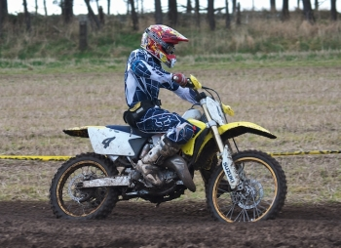
Disaster struck Hamish Patrick on the first corner in the Clubman Class, he went down and broke his collar bone and unfortunately this will rule him out of the first round of the British Enduro Championship next week. Liam Beaty had no such problems and won the class with ten laps completed, just one short of the top Experts, Oliver Hart finished second with James Harvey third. In the Clubman B class Pawel Reuter was keen to start the year with a win as he has his eye on the Championship this year. Roger Summers finished second with Ivan Williamson third.

Liam Lamb hit the top spot for the first time in the Sportsman Class following a great performance leading all the way, Stuart Jenkins finished second and Tim Irwin third.

There was a two hour Motocross Class held within the event for riders who did not want to ride through the forest. The motocross A class was won by Chris Galloway followed by Michael Graham in second place with Sandy Pate on his Kawasaki third. Andy Macfarlane won the motocross B’s with Mickey Oates Motorcycles’ David Fergus second. Bob Jack was flying in the first few laps, leading for a while before a fall on an icy hill dropped him down to third.

The last event for this winter at Lochhouses will be the third round of the 2008/9 Melville Motocross winter series on the 1st March. Regulations are available on the downloads page at www.melvillemc.co.uk

