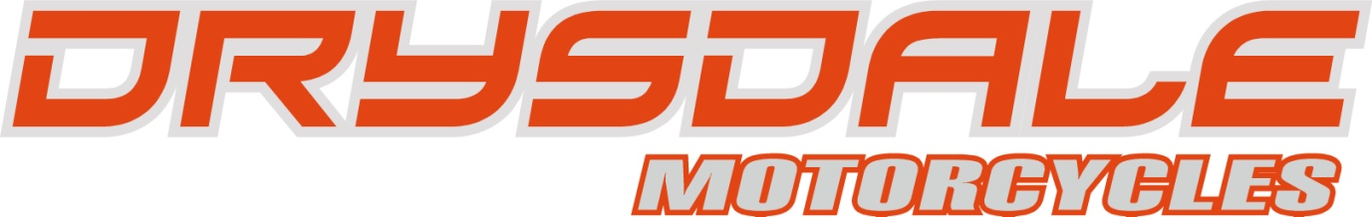

Drysdale motorcycles test day January 31st 2010

Dear valued customer,
Winter is here and there is not much cheer and the January blues are not far away, but that’s okay because it’s almost time for our legendary enduro bike demonstration test day!
We are hosting the event at the famous Loch houses enduro circuit in East Lothian, one of Scotland’s top enduro venues.
There will be the very latest models on test from KTM, the full range of models including the 125EXC, 200EXC, 250EXC, 250EXC-F, 300EXC, 400EXC, 450EXC and the 530EXC.
Also available to test will be the exciting new HUSABERG enduro range, the 390FE, 450FE, 570FE and the 450FX.
The event kicks off at 9.00am and we will be running 20 minute sessions every half hour, through to 3.30pm or when bad light occurs.
Pre- booking for this event is the only way you get to this event and there are limited spaces so book your place now!
The cost per rider per machine will be £30 for one bike or £40 for two bikes payable in advance.
You will also be able to take your current machine out on track to do back to back comparisons with the new models.
Photo identification will be required on the day, Drivers licence or passport and this must be produced prior to riding.
Bookings can be made by e-mail, by telephone or by simply popping into the shop.
The address for the venue is as follows: Loch Houses enduro circuit, west Aniston farm, Tranent, East Lothian, EH33 1EA.
We look forward to seeing you there,

The Drysdale motorcycle team.

