To ensure our e-mails always reach you, add touruk@beta.maileasy.se to your address book.
Is the e-mail below not displayed correctly? Click here to view it online.

DAWN TO DUSK 2009 IS FAST APPROACHING
ONLY 5 WEEKS TO GO

GET YOUR ENTRY IN NOW, WHILE SPACE REMAINS

With only 5 weeks to go until the start of the 2009 Dawn to Dusk, entries are still coming in thick and fast. With the addition this year of the 24 hour race, interest in the event has been growing by the day.  This years track layout is going to plan with a main lap of about 16 miles currently being mapped out. When darkness descends on the 24 hour race this 16 mile track will be cut down to a shorter 10 mile unlit track which will still, despite it’s length, be classed as completing a full lap. So if you’re a good night time rider this shorter lap gives you the perfect opportunity to bag some much quicker laps than during the day (or will it!!!!!).  The official closing date for entries will be August 11th and although we will accept entries after this date there will be a late entry fee of £20 so get your entries in soon to avoid this fee. After this date the full entry list with rider numbers will be posted on the Dawn to Dusk website. | 

Additional lighting – Dawn to Dusk special offer

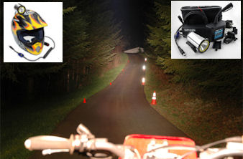 | Most of the night time 10 mile track will be unlit so lighting will be imperative in making the most of these shorter laps.  To assist with this Dawn to Dusk are offering all participants the opportunity to kit themselves out with some high quality lighting at a 25% discount off the RRP.  Read more....

Take on 2006 12hr winner Steve Ireland in the 24hr race

Steve Ireland, Founder and owner of WOR Events will this year be taking part in the 24hr race in the marathon class to raise much needed funds for the Childrens Adventure Farm Trust, an organisation that caters for disabled and under privileged kids.  Steve, who won the 2006 Dawn to Dusk 12hr race is a rider to watch as he has the skills and, with the drive to get as much money for the charity as possible, the motivation to win.  To read more about Steves assault on the Dawn to Dusk, sponsor the man himself and find out more about the great work the Childrens Adventure Farm Trust does, please click here.... | 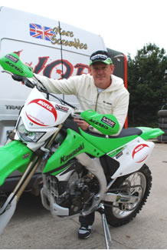

Dawn to Dusk on DVD
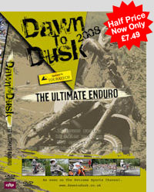 | Want to find out more about the Dawn to Dusk?  The Dawn to Dusk DVD follows motorcycle adventurer Austin Vince as he goes behind the scenes to find out what makes the competitors and organizers of this unique event tick.  Watch the thrills and spills of the event and see why people come back year after year.  Copies are currently available for half price at only £7.49 (usual price £14.99). You can watch a five minute trailer HERE, or buy the DVD either online or by phone with Touratech on (01639) 841765.

For any more information and entry forms visit http://www.dawntodusk.co.uk/ or contact info@dawntodusk.co.uk

Dawn to Dusk Racing Ltd - Unit 14 Woodlands Business Park, Ystradgynlais, South Wales, UK, SA9 1JW
www.dawntodusk.co.uk
information@dawntodusk.co.uk
This e-mail was sent to charlie@scottishenduros.co.uk.
To unsubscribe from this newsletter, click here.

