Scottish riders report from the Muntjac Feb 2009
By Campbell Chatham

David Knight pulled back 6 seconds on the last test of the day to take the win at the first round of the Metzeler British Enduro Championship. Very close times were the order of the day in all classes at this extremely competitive enduro.

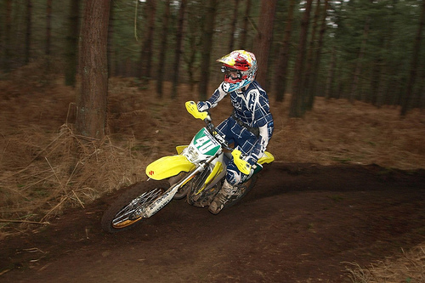
The weather was perfect and the ground bermed up beautifully to provide ideal riding conditions. 232 riders entered within four days to ride in one of the best events of the year. There was the usual buzz in the air for the start of the season although all agreed that this was looking like one of the most competitive championships for some time.
Neil Chatham on the new Suzuki

Ten Scottish riders made their way down to Suffolk for the start of the 2009 season. Euan McConnell was the top Scottish performer on his new Aprilia 450 V twin, by far the quietest bike on the day, 6th E2 and 12th overall as he learned how to ride this very different machine. Ricky Mair was out on a reliable and powerful Suzuki RM250 which was all he needed to see him return to the British Enduro Championship. Ricky was able to ride in his spectacular style to 7th E2 and 13th overall. Richard Hay won the E1.2 class and finished 15th overall on his Dennis Irvine Superbike KTM, Richard’s pace on the course saw him only drop one minute at the finish with just a handful of riders cleaning the time sheet and Kevin Murray finished 12th E2 and 25th overall on his Yamaha.

In the Expert Class Derek Little was running in the top five until he clipped a tree, came off and took a blow to his ribs with the handle bars. After sitting beside the track for a few minutes he decided to continue, on the fourth lap the pain proved too much and he was forced to retire, the pain must have been bad as Derek is a seasoned campaigner. Neil Chatham had to carry the honour for the Scots in the Expert Class with Dereks’ retirement, Neil thoroughly enjoyed his first Enduro on his Drysdale Motorcycles Suzuki RM125. 4th E1.2 and 9th overall was Neil’s reward for a mature ride without a fall all day and special test times that will give him confidence for the future. Allyn Scotland was running well until his security bolt snapped and his tyre came off the rim. Allyn managed to get the tyre back on but it was just spinning round the rim resulting in his retirement.

Fraser Norrie just missed his dream debut in the Clubman class finishing second overall although he did win the E1.4 Class as compensation. Fraser suffered with traffic in his second special test as he was running number 123 that saw him mixing it with the mid pack. There was trafficon Frasers final lap that cost him a minute although no riders made it clean on time in the Clubman class. Neil Paton also travelled down with Allyn Scotland for his first British Enduro, unfortunately his bike kept cutting out and proved difficult to restart. Neil struggled on but had to call it a day at the end of the third lap.

Keeping the best until last, the story of the day for the Scottish riders was D3 Racings Murray Thomson who pulled himself up to the top of the veterans leader board. This is not Murrays’ favourite event and it was obvious from his special test times that this is not his speciality, sitting in third place after the first test.. With tight times Murray was able to show his talent on the course on the last lap, the only rider to clean the time sheet Murray took the win ahead of Carl Tiley and Jack Twentyman, a truly heroic performance.

