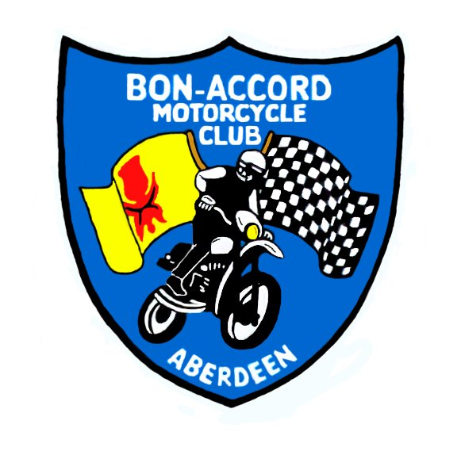

Bon-Accord Motorcycle Club Ltd

SACU SOLO CHAMPIONSHIP: HARE & HOUNDS
SACU QUAD NATIONAL: HARE & HOUNDS

Netherley Moor, Netherley, Aberdeenshire
Sunday 22nd November 2009
SACU Permit No: 09159
.
Quad Scrutineering Starts 9:00
Solo Scrutineering Starts 9:30
.
Quad Race Starts 10:00
Solo Race Starts 12 noon

Supplementary Regulations

Organised under the rules of the SACU and the Standing Regulations of the ACU for Hare and Hounds events, together with these Supplementary Regulations.

Eligibility
Open to any type of off-road machine, Adult solos only. (Expert), (Over 40’s),(Clubman),(Clubman B) and (Sportsman). Riders aged 16 & 17 must have their entry accompanied by a signed Parental Agreement Form.
All Quad adult classes eligible.

Closing Date
Entries close Wednesday 18th November. Please send with your entry at least one stamped self addressed envelope for your rider number, but if you wish a copy of the results as well, then please send two.

Venue
Netherley Moor, Netherley, Aberdeenshire. Sign posted from the A90 northbound carriageway of the Stonehaven bypass. Follow the B979 Netherley road 2 ½ miles to start area. (see enclosed map)

Signing On
Commence at 9am. Competition licences must be shown - one-event licences are available if no licence is shown.

Scrutineering
Scrutineering will be carried out under SACU Hare & Hound Regulations. Riders are to present themselves to the
scrutineers with helmet, dog tags, boots, gloves and their machine. All machines must be scrupulously clean.

Race Start
Machines should be brought to the starting line 15 minutes before the start time.
All races start with dead engines – Le Mans type start – riders at opposite side of track to machines – mechanics to hold machines upright. Experts first away then clubman and so on.

Race Duration
Quads – 90 minutes, Solos – 3 hours. Ties will be decided upon number of laps completed and riders on the same lap will be placed in order in which they took the chequered flag

Lap Scoring
Each class will have its own lap scoring gate. Every competitor must ride at walking pace through this gate, to enable the lap scorer to take their number. Competitors must go through their correct gate to be awarded the lap. Riders must take the chequered flag at the end or they will be classed as non-finishers.

Results
They will be posted on www.bamccc.co.uk and www.scottishenduros.co.uk and mailed to all competitors who have supplied a stamped SAE.

Awards
In each class at championship rounds the first 15 finishers shall be awarded points at the rate of 20,17,15,13,11,10 down to 1.

1

Refuelling/Repairs
Can only allowed in the designated PITS/REFUELLING area. Every competitor should have a fire extinguisher adjacent to his fuel. Engines must be stopped while refuelling - environmental mat should be used while machine is at standstill & fuelling. Only riders, officials and 2 authorised helpers per rider are allowed in the pits & refuelling area.
ANY MACHINE/RIDER WHO LEAVES THE COURSE OR PITS AREA WILL BE DEEMED TO HAVE RETIRED.

Exclusion penalties

Smoking in Refuelling Area
Refuelling with engine running
Refuelling other than in Refuelling Area
Course cutting or riding in opposite direction to the course
Outside assistance except in Refuelling Area
Changing Machine during event
Excessive speed in Lap Scoring Area.

Protests must be presented to the Secretary within 24 hours of the publication of the results.

Officials
Clerk of Course: Ken Whittaker
SACU Steward: Charlie McKenzie
Chief Scrutineer: Robert Prodger
Secretary of meeting: Di Stuart, 3 Woodview Place, Stonehaven, AB39 2TD

Preferred Rider No:
If you have a number on your bike and would like to keep it just put a note on your entry and I will try to give it to you if possible.

The Bon Accord Motorcycle Club Ltd.
A Membership form is enclosed with your entry in case you would like to join our Club. Membership is £15 and will expire 12 months from date of joining.

Information from the SACU:
Once again for 2009 clubs are to remind riders that there is no temporary disablement insurance carried on the event insurance. You can obtain one event – or full season insurance on a personal basis by applying to Alexander Forbes Motorsport Risk Services – Tel 0161 228 0721 or e-mail to lubyd@aforbes.co.uk.
Clubs must check that any non ACU or SACU riders have appropriate start permission from their respective Unions eg MCUI of Ireland. This ensures they have repatriation insurance in case of injury. If this effects your entry please bring it to my attention.

Basic Rules of a Hare & Hounds
- Go through your correct gate
- Go through slowly so your number can be recorded
- Take the chequered flag to finish the race

The Course
The course will be mainly over fields and heather moor.

First Aid Cover
We shall have Paramedics in attendance.

2

