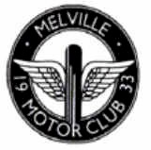
Melville 1st March Motocross
Lochhouses farm in East Lothian hosted the final round of the Melville Motor Club Winter Motocross series. The weather held up again with some glorious sunshine delighting the organisers and the 148 riders.
Stuart Flockhart held a training day on the Saturday which proved very enjoyable and informative for the promising young riders who attended. The day was split into a morning and afternoon session with different areas on the track providing tips from Stuart the ex British and World championship competitor.
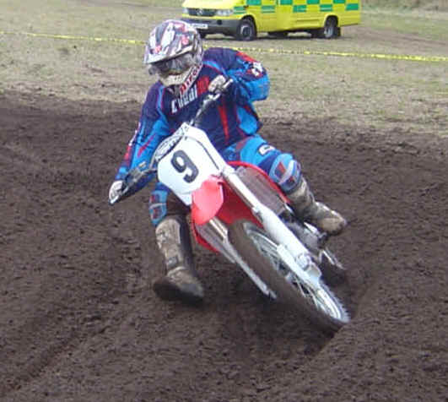
The track was graded after the training meaning the early races on Sunday were very fast leading to some great racing. In the first A Class race Colin McLuckie (left) led his tutor Stuart Flockhart for the first two laps until a mistake by Colin handed Stuart 'Disco' Flockhart the win. A mechanical problem saw Stuart drop out of the second race and Tony Craig won again ahead of Colin McLuckie. Peter Kelly was mister consistent with third place in every race taking the overall win in this very competitive class as it was Tony's turn to drop down the order with problems in the third race. The final standings at the end of the day, Peter Kelly first Colin McLuckie second and Tony Craig third and despite two race wins at Lochhouses Stuart Flockhart finished ninth.
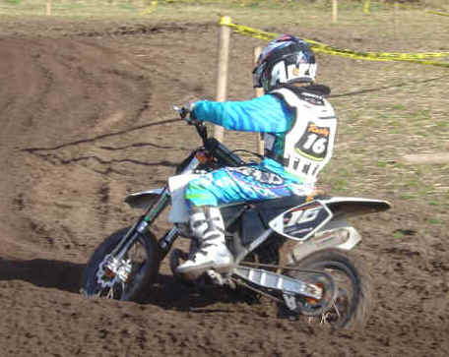
In the B's Neil Chatham continued his winning ways and he is looking forward to moving up to the A's for next years series. Neil was unable to compete last year as he had glandular fever and more than made up for missing out winning every heat. There was a separate race for the B's as there was enough daylight to run a full programme of races with Stewart Rae finishing second and Gary Turner third.
The C class was full long before the closing date and provided great entertainment for the spectators and they never knew who would end up on top. In the first race Danny Stewart won with Sandy Pate second. To the delight of proud Dad Dave Pate the second race was won by Sandy Pate taking the overall win at the end of the day with Danny Stewart second overall. The final race was won by Simon Cockburn with Steven Currie snr and Iain Martin battling it out all day banging handle bars with Steven grabbing the final step on the podium in the overall results.
There was some fast action in the Youth MX2 class with Jake Boyes and Fraser Flockhart (no relation to Stuart) chasing each other way out in front of the pack. In the first race Jake was well in front with Fraser in pursuit, in the second race Fraser took the holeshot and defended his position really well in the early laps until a huge crash saw him take a trip to hospital with a suspected broken wrist. Jake went on to win all the races with Stewart Treloar second and Russell Valentine third. Frasers EX ray later showed no broken bones.
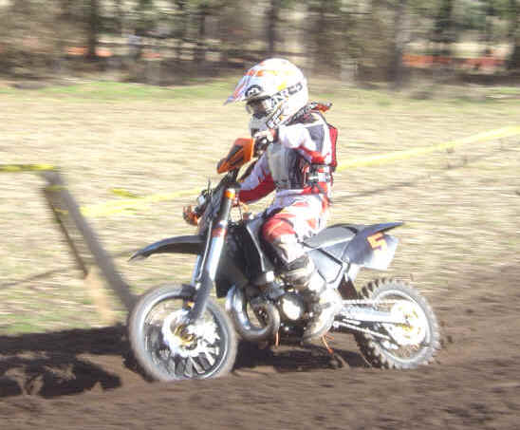
The big wheels 85's saw a master class by Matthew Fleming once again winning all the races. Peter Graham finished second with Andrew McNicoll third. The small wheel 85's were in the same race with Greg Queen winning all the way and John Adamson battling all day to take second over Sean Williamson third.
In the 65 Class Kyle Peebles (left) hit the top spot in every race looking very confident in the sand with Bradley Mann (right) challenging for the lead whenever the opportunity allowed and Scott McLean came home in third.
Autos As always the Autos had their own track and the weather was a real bonus for these young riders. Jordan Gill won the Auto class with two wins and a third, Lyle Crothers won the final race of the day finishing second overall and Andrew Williamson finished third.
Quads
The Quad Class was dominated by Gavin Dodds who won every race, the retired road racer club was also out in strength with John Crawford finishing second with Richard Telford third. The quad class had a good turnout following a warning of 'use it or loose it' ultimatum from the Melville club, hopefully the Quads will continue to be welcomed to winter series as long as they enter early and don't cancel at the last minute.
Results
Adult A 1 Peter Kelly 2 Colin McLuckie 3 Tony Craig 4 Simon Graham 5 David Houston 6 Drew Harvey
Adult B 1 Neil Chatham 2 Stewart Rae 3 Gary Turner 4 Paul Benham 5 Bobby Jack 6 David Lawson
Adult C 1 Sandy Pate 2 Danny Stewart 3 Steven Currie Snr 4 Iain Martin 5 Simon Cockburn 6 Dave Williams
Youth MX2 1 Jake Boyes 2 Stewart Treloar 3 Russell Valentine 4 Ryan Johnson 5 Thomas Robertson 6 David Scott
Big Wheel 85 1 Matthew Fleming 2 Peter Graham 3 Andrew McNicoll 4 Paul Baillie 5 Ryan MacDonald 6 Kyle McNicoll
Small Wheel 85 1 Greg Queen 2 John Adamson 3 Sean Williamson 4 Reese Wilson 5 Jack Taylor 6 Robert Bell
65's 1 Kyle Peebles 2 Bradley Mann 3 Scott McLean 4 Lee Perfect 5 Frankie McDonald 6 Brett Bailie
Quads 1 Gavin Dodds 2 John Crawford 3 Richard Telford 4 Ian Neill 5 Davey Nixon 6 John Paterson
Autos 1 Jordan Gill 2 Lyle Crothers 3 Andrew Williamson 4 Daniel Chisholm 5 Scott Russell 6 Dominic Stevenson
The Melville motor club will now concentrate on running five rounds of the Scottish Enduro Championship with possibly two Hare and Hounds at Dolphinton near Penicuik in the summer. All information is available at www.melvillemc.co.uk

