BEC Round 4 – Natterjack Enduro 26/27 Sep 2009

Neil Chatham wins E1/2 and takes second overall Expert at Natterjack scorcher!

Neil Chatham had a rollercoaster weekend culminating in 1st E1/2 and 2nd Expert overall at the Natterjack Metzeler British Enduro Championship.

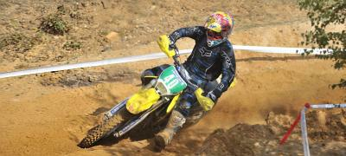

Photo from Action Sport Photography
Neil was feeling a little under the weather before the event and even the brilliant sunshine could not raise his spirits although once the adrenaline kicked in he was pushing as hard as ever. The first decision was whether to climb the wall in the extreme test or take the slightly longer easier route. It was decided that he would ignore the wall and push round the easier route to avoid damaging his bike or himself as a good result was the priority. The second decision was whether to do the big jump in the sandy motocross test, Neil had discussed it with Paul Edmondson and he reckoned that it could not be done on a 125 although when he was 19 he would have had a go. On the second run at the motocross test Neil cleared the jump setting his fastest time so far with Johnny Little and Jimmy Ballantyne witnessing the spectacle, they did not think he was going to make it as he was so sideways but clear it he did. At the end of the three laps Neil was leading overall by a fraction of a second and headed into the final two Enduro tests behind the Championship riders, unfortunately one of them became stuck on the logs and blocked the course for Neil, if he had gone through the tapes he would have been excluded, he had to wait until the un named rider cleared the logs costing him 16 seconds and the overall win by just 6 seconds. Third overall and second E1/2 was his best result so far although there was a little disappointment at missing out on the win.

On day two Neil was still feeling unwell and could not eat very much and two crashes in the motocross test meant an uphill struggle. Neil pulled all the energy he could muster for the final motocross test and redeemed himself setting the fastest Expert time for the day. 4th overall and 2nd E1/2 was enough to win the E1/2 class and finish second overall for the weekend. Although disappointed not to take the win he was satisfied that his special test times were up with the Championship class.

‘Thanks to all my sponsors and supporters, I have progressed a great deal this year in the British Championship and I am continuing to build my experience and pace on my Suzuki. Drysdale Motorcycles have given me great support and I am now focusing on a podium finish in the Scottish Expert Championship. Thanks also to Suzuki GB, Metzeler tyres, Fox and Shell.’

