Bon Accord MC SACU Championship Enduro

Craiglash Forest Banchory 4th Oct 2009

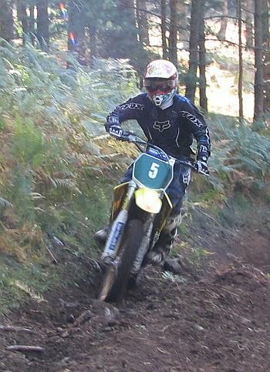
The penultimate Scottish Championship Enduro was held near Banchory 30 minutes east of Aberdeen. This was a new location with the riders arriving on Saturday afternoon to walk the test where it became obvious that this would be a very different Enduro. The marshals were all riding trials bikes as the course was rocky and steep, one section of the special test was nick named ‘collar bone alley’. The experts completed five laps with the clubman on four and the sportsmen three. A beautiful day welcomed everyone on Sunday morning and there was apprehension in the air as no one knew just how hard they would have to push in the rocky test.

Deeds Raymond was over from Australia for the first time in ten years, Deeds and the East Lothian crew looked a little worse for wear as they had ended up in a local ‘Club’ until 3.00am. Deeds won a medal at the ISDE in Sweden as part of the Scottish team in the 80’s.

With Derek Little the Scottish Championship leader and Grant Smith currently in second on their way to Portugal there was everything to play for. The Championship has seen 8 winners in the 9 events so far as the Championship has become ever more competitive.

All the Experts made it round easily within the time allocated, only Allyn Scotland making a mistake on his time card and loosing valuable points as a result. The first special tests were clear of traffic and there was more grip available than the riders had expected. The difficulty in the test was to balance speed with caution over the rocks. At the finish the talking point was who had made it through the traffic in the later laps, with stories of the riders fighting their way past the Sportsmen. Neil Chatham came out on top winning with the quickest times in all the tests, his confidence was up following his E1 win at the Natterjack British Enduro Championship the week before. Frazer Norrie also returning from the Natterjack with a class win and the British E1/4 Clubman Championship secured finished second, Frazers maturity at such a young age to master these tricky rock sections beggars belief. Murray Thomson who was expected to excel in these technical conditions but he was caught out trying to pass a back marker, spinning his bike around and costing him valuable time. David Vass came out to play at this round and finished fourth with Allyn Scotland with his time card error fifth.

Scotland has a new young sensation with Frazer Flockhart wining the Clubman Class at his first Enduro. Fraser needed special dispensation from the Scottish Enduro committee to ride as he is not sixteen until next month. Fraser had to pass a competency test to be covered by the all important insurance company. It is great to see young riders coming through and Fraser will be a force to be reckoned with for the future. David McArthur was beaten to the overall by just two seconds. David was the master of consistency with an identical test time on every lap with Ryan Bruce third.

Steven Currie Junior moved up to the Clubman B class having secured the Scottish Sportsman Championship and continued his winning ways taking the class win. Steven will be riding the Clubman Class next year. John Allan finished second eight seconds behind with Roger Summers third.

Gavin Johnston fancied his chances at this round as his trials skills should have helped him in the tricky test, unfortunately for Gavin the hard charging Sean Woolley man handled his KTM to the top once again winning by 9 seconds with Alex Kirk third.

Alastair Millar won the sportsman class six seconds ahead of Daniel Boddington with Alan Maclean third.

The final round of the Scottish Championship is the rescheduled ELRAT Enduro at Aberfeldy on the 25th October, hopfully the ground has dried out enough to give all the riders a decent day out. In the Expert class Derek Little has all but tied up the title with only Grant Smith within a mathematical chance of overhauling him. Third place is very much up for grabs between Murray Thomson, Frazer Norrie and Neil Chatham. Murray and Frazer have rounds to drop although Neil has had to pull himself back up the championship table following two injuries resulting in DNF’s earlier this year.

All the focus is now on the ISDE team in Portugal and we are all hoping the Scottish Team all come home with medals.

