Morocco Training Report 2007 – Paul Carlyle

The Webmaster insists on a report – and we all know the Webmaster decides whether the photo of your embarrassing crash at the next enduro goes on the web-site – so we all obey the Webmaster.

The desert is not kind to shoulders. An operation to repair damage to my right shoulder (sustained during the Enduro d'Agadir 2006) meant no real riding in 2007 between March and October. Consequently, the opportunity to spend a November week training in Morocco with Patsy Quick, Clive "Zippy" Towne and the Team Desert Rose Dakar entrants was just too tempting.

The Rallye bike was delivered to Patsy in Sussex and then she shipped them all out to Ouarzazate in southern Morocco. A fair bit of work had been done on the bike over the summer so she was looking quite neat for one of my bikes.

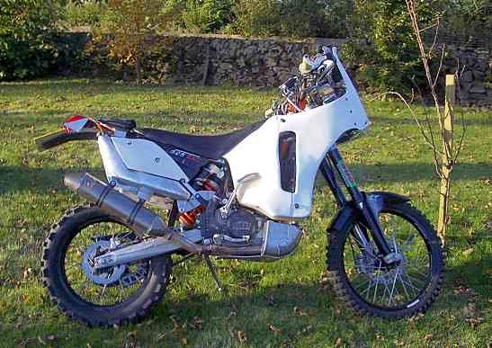

KTM 525EXC Mecasystem – As built by Ian Myers and "pimped" by P Carlyle – before the crash(es)

Kiwi Mike Shepherd and I met at Heathrow a few weeks later and started to wonder at the collection of KTM orange shirts hanging around. You just kind of walk up to people carrying helmets and it usually turns out you are all going the same place. The orange shirts turned out to be the "Scotland to Dakar" (www.scotlandtodakar.com) boys.

Late night – early start – big line of KTM525EXC Mecasystem machines lined up outside the hotel in Ourazazate, along with some rented 450EXCs. Patsy Quick and her team had been working flat out late into the night to get the bikes all ready for the Dakar boys.

Breakfast briefing then the first day of riding on a GPS route to Tinihir. Tracks I had ridden before but couldn't quite remember – a dangerous mix. Riding with Mike and Dakar entrant Duncan Tweedy we were taking it easy on the new bikes. The Rallye bike is pretty heavy to push around but rides nicely once you get going. The 525 grunts along a bit like an old XR400 – nice and dependable with plenty of torque to blip over any little rocks or ditches.

I ran out of fuel at almost 150km exactly but on investigation the fuel line for the right hand front tank was not properly connected so once pushed home the fuel started to glug through into the left tank and we were away again.

Lesson One – push the dry break connection fully home – but good to know I can get 150k per front tank - albeit with no sand riding.

Towards the end of the day the three of us had made a few navigation errors so we missed the cut off time to run the final loop from the fuel stop. So instead – coffee at the fuel station then 60k on road to the hotel. One of the riders on a 450 managed to rip off a casing on a rock somewhere – he was fine but it looked like his week of riding was over. Desert 1 – Riders 0

Lesson Two – when you fill all four tanks the front tanks are higher than the rear ones so, unless you turn the fuel tap to "Front only", fuel will run out of the rear tank breathers until they level. Which would mean maybe 3 litres of lost fuel.

Arriving at the hotel with plans for a cold beer we were rudely awakened by Patsy. No messing about – get the head torch on, the oil changed, oil filters changed, radiator levels checked, new air filter, check every bolt and stud around the bike, repair anything that needs it. Patsy wanted the Dakar boys to get used to working on their bikes in the dark and in the dust.

Lesson Three – a good head torch and complete toolkit are essential. "…can I borrow that 12 mil socket again…"

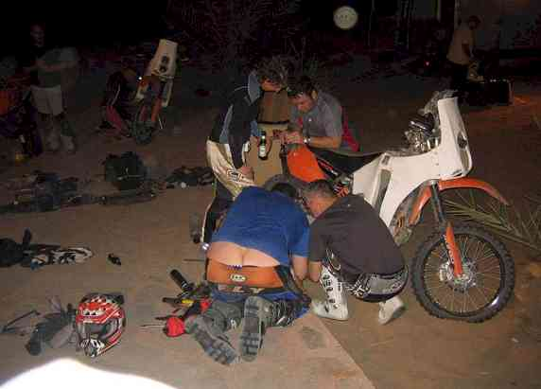

Patsy, Philip, Duncan and Oz "Crack of Doom" get down and dirty with a cracked exhaust weld

Day 2 – GPS track again. Nice tracks with a few deep Oueds (dry river beds) to cross. One of them took us a while to find a way out of but Duncan, Mike and I were careful to ride around a suspicious looking damp patch of clay in the middle of the river bed.

We were tramping on and rode straight past the lunchtime meet up point way early. Then the afternoon had us in dunes and camel grass. Mile after mile of it. No way to get up speed. This was where the size of the Rallye bike made itself felt.

It turns out that the wee bit of damp clay was a big mud-hole. John from Leith (via Swindon) buried his 450 in it a while after we passed. He got so tired digging his bike out that he had a crash further on and broke his collarbone. Desert 2 – Riders 0. He's apparently planning to enter the Dakar on an AJP250!
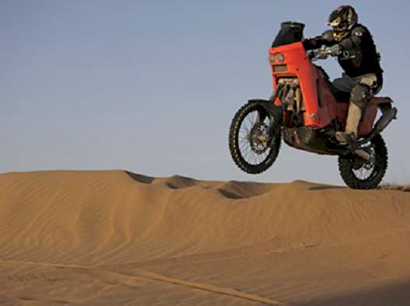

Gary Ennis shows how its done on his KTM 660

Day 3 – Very exciting! Our first day on a Dakar roadbook. We are to ride half of special stage from Erfoud but stopping at Merzouga on the far side of the first dune crossing using the 2006 Roadbook. Patsy and Zippy gave us a bit of a briefing on marking up a roadbook the previous evening and many a worried hour was spent with highlighter in one hand and a beer in the other. If you are interested in Rallyes – read the article by Reuben Welsh on marking up roadbooks and using them – invaluable.

Lesson Four – As you work through the roadbook scroll, scroll it up so that the last bit is on the outside – DON'T scroll it back to the beginning again as you'll load it into the roadbook holder backwards next morning – ie from the end not the beginning. No-one would be daft enough to do that would they!

The first hour or two were on rough tracks and the roadbook was taking up a huge amount of concentration. I soon found you could relax with it and the hazard warnings are more for the cars and trucks. Unless there is a "!!!" warning, there's really not much to worry about. Certainly no need to slow down to first gear for a "!" warning – no-one would do that would they?

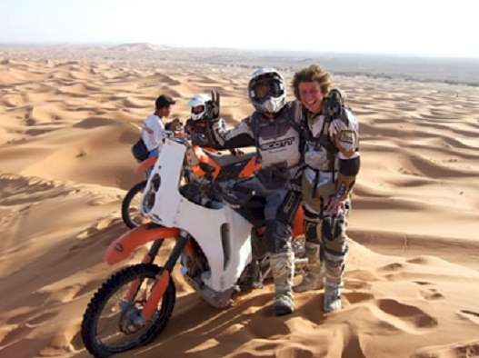

Mike Shepherd and Patsy Quick at Merzouga

Lesson Five – if you need to check a compass bearing from your GPS against the roadbook, don't just stop, the GPS will be wrong. Roll to a stop in a straight line for 5 to 10 metres and the GPS will give you a pretty accurate bearing.

Day 4 saw us running the second part of the roadbook special stage to Tamgroute and then 35k on the road to Zagora. Late morning we came out onto a wide flat salt plain – and smack into the middle of a Car Rallye. This was the true Dakar experience – dodging in the dust from Bowlers and Toyotas and being buzzed at head height by the TV helicopter.

Having worked our way past the majority of the cars (they were slower than the Dakar guys) we were up in the hills on a rocky piste when my front wheel kicked left and my bike and I went off the piste into a pile of rocks. I went over the bars and snapped my left collar bone. Desert 3 – Riders 0

Mike and Duncan helped put the bike back together – I lost my smart carbon front mudguard and bashed up a fair bit of the rest of it. We had to straighten the left tank mounting to get the seat back on. A French Toyota from the Rallye stopped and lent us the "…12 mil socket…"

I still managed to keep up enough speed to the end of the stage that we were the first group to the end – even with Mike running out of fuel twice and Duncan and I having to dump fuel from our bikes into his.

Lesson Six – If you've only got a small bit of fuel in the left tank it might not be enough to push the fuel through the filter into the fuel pump. The trick is to cover the tank filler with your mouth and blow into the tank to push fuel through.

So that was kind of it for me. I rode the road section rather than the piste up the Draa valley from Zagora to Ouarzazate the next day (I'd ridden the pistes before) and we all packed up that night. Six weeks later my KTM is still in Sussex with Patsy as she gets ready for the Dakar and orders up parts for me. I learned a huge amount from Patsy, Zippy and Clive and from all the Scotland to Dakar boys and the other riders. Using the ICO and roadbook was a lot easier than I thought it would be but still challenging at times.

So best of luck in the Dakar 2008 to all the guys who were out in Morocco – Duncan Tweedy, Gary Ennis, Neil Buchan, Ewan Buchan, Calum McKenzie, John Whiteford, Iain Shankie, Philip Noone and to Patsy, Clive and Zippy who've got to take care of them all.

