Rhayader Scottish Riders Report

Euan McConnell who tied up the E3 British Championship at the weekend crowned a great weekend for the Scottish riders at the Rhayader British Enduro Championship.

Fabulous weather greeted the competitors on Friday and the warm temperature continued for the weekend. The sky was overcast and it remained dry ensuring perfect riding conditions.

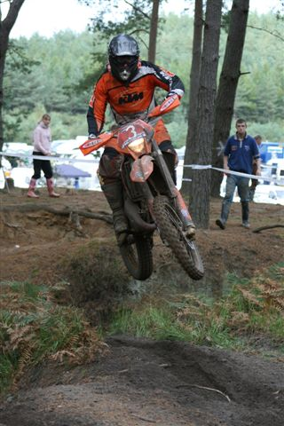
The parc ferme and one of the refuelling checks was based in the centre of the 5mile special test, which made viewing easy and enjoyable for the pit crews. On Saturday morning there was a thick mist, which made the special test very slippery, some riders including Euan McConnell fell on the 100yard stretch before the start of the test. Euan did not make many more mistakes after that, finishing fourth overall for the weekend. Sunday went down to the wire when the win could have gone to any one of the top four including Tom Sagar who went on to win or Simon Wakely and, of course, Paul Edmondson. Euan pushed his TM 300 to the limit, and finished just behind Tom Sagar. Euan has won the E3 class at every round of the Championship clinching the title with three days remaining. Euan spent Saturday night packing his bike ready to represent Great Britain in Chile in November.

A badly damaged hand did not stop Richard Hay finishing just outside the top ten in the Championship Class. Richard had clipped a tree at the Crychan and his hand was swollen, during the pit stops he never complained and rode on never dropping a minute all weekend. With no time penalties Richard finished 7th E1 and 11th overall.

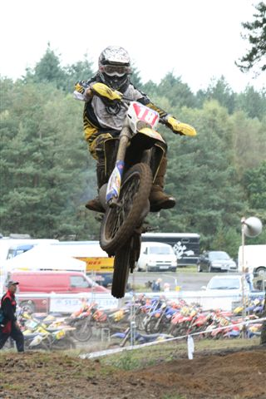
Scottish Champion Murray Thomson does not enjoy motocross special tests and a fall on the very first test in the misty, slippery conditions set the tone for the weekend for the mud specialist. Murray never lost any time throughout the weekend and he was happy to pick up as many points as he did. The dusty test with big jumps was not Murray’s favourite, although he pulled himself up to 8th E1 and 13th overall Expert. There is a picture of Murray with both wheels in the air allegedly Tracy has a copy!

Derek Little went out on Saturday on a mission, he showed a blistering pace and set the second fastest Expert special test on Saturday morning. Although he slipped a couple of places over the weekend Derek was out to prove a point and finished 2nd E1 and 4th overall in the Expert class. Derek managed this with a faulty front brake, or maybe because he had no front brake, you’ll need to ask him. On Friday he had bled the front brake and it still caused problems on Saturday, Derek worked on the brake again on Sunday morning and it performed much better for the final special tests.
Derek’s dad Johnny said it would never have happened if he still had a blue bike.

The weekend had some very tight finishes despite the test taking around 10 minutes to complete. Neil Chatham had finished 1st E1 and 3rd Clubman overall on Saturday, his best result at a British Championship this year. On Sunday he fell in the first test and once his dad had done the calculations it was realised Neil was second in the E1 Class by 0.06 seconds. The challenge was to finish ahead of Mike Bailey in the final special test at the end of the day and if he could beat him by 3.45 seconds, the E1 win for the weekend was up for grabs. Neil went on to set his fastest time of the weekend and clinched the E1 win. With two E1 wins under his belt this result has pulled Neil closer to the top 3 in the E1 Clubman Championship.

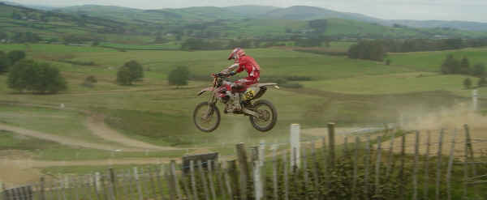

Neil Chatham flies in the test

Graeme Naismith blew up his Yamaha 125 the weekend before the Rhayader. Graeme had to beg and borrow parts from Ride On and Mickey Oates in Glasgow to have his bike ready for the event. Graeme was not sure what had caused the problem and spent the weekend willing his bike to the finish. In typical Naismith style he won the Veteran class on Saturday. On Sunday it came down to the wire, Graeme finished just 1.15 seconds ahead after the first special test and he finished just 0.05 seconds in front
at the finish giving him the overall win for the weekend.

The final round of the Metzeler British Enduro Championship is at the Natterjack on the 29th and 30th September. There are a couple of very close points between riders and it will prove a very exciting weekend with some professional diggers coming in to build the sandy special test.

