Grampian Motorcycle Club
SACU Scottish Enduro Championship 2007
Iain McKenzie Memorial Enduro : Monaughty Forest, Elgin
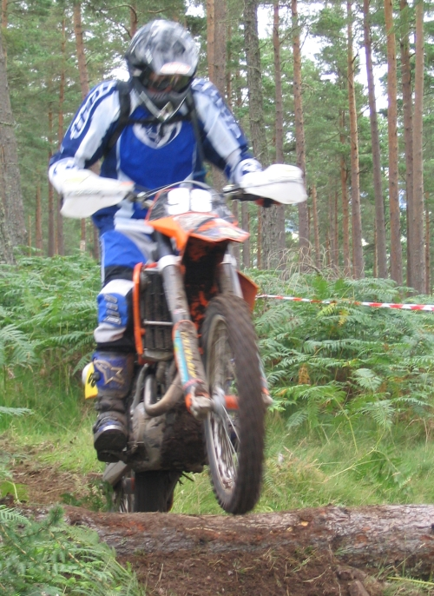

5th August 2007

Venue:-

To be held at Monaughty Forest, sign posted from A96 between Elgin and Forres
- Assembly will be at 8.30 a.m.
- Scrutineering from 9 – 10.00 a.m. Penalty for late scrutineering – 60 points.
- First man leaves at 10.31am

Route:-

The course will be approx 15 miles of forestry going marked by tape, rope and day-glow arrows.

Eligibility:-

- Expert, Clubman, Over 40’s, Sportsman and Trials classes. . Clubman entries will also be classified on capacity E1 E2 E3

Clubman Capacity Classes
- E1 2 strokes 100cc to 125cc and 4 strokes 175cc to 250cc
- E2 2 strokes 175cc to 250cc and 4 strokes 290cc to 450cc
- E3 2 strokes 290cc to 500cc and 4 strokes 475cc to 650cc

- One-Day Licences will be available on production of proof of Club Membership. So if you have a licence or registration card please ensure that you bring it to avoid any additional charge.

Entry Fee:- £35.00

Closing Date - Monday 31st July. Completed entries to be returned to – John Little, “Pine Dell”, South Troves, Elgin, Moray, IV30 8RD Tel. 01343 860626

- Include 2 S.A.E’s. for riding numbers and results!
- Include 1 S.A.E for riding numbers if you can get results from the web.

Scrutineering:-

Riders must sign on prior to scrutineering. Riders must present their machines along with an ACU approved stamped helmet, a dog tag (I.D. Disc with Name, Date Of Birth And Blood Group, if known). Note: Helmets will be checked again at start line (so those of you who present a different helmet for scrutineering than what they actually use to race will not be allowed to start). Please ensure you have Yellow side panels with Black numbers on all three sides of the machine.

Starting:-

Each rider will receive a time card at signing on for the days run. At the beginning of the enduro, each rider will receive a starting signal at the exact time he is due to start.
Within one minute of the starting signal having been given, the rider must start his motorcycle at the starting line and cross another line 20 metres from the starting line under engine power. If a rider is not at the starting line when the signal is given to start, he will not be penalised providing he brings his motorcycle to the starting line, starts it and crosses the 20 metre line within one minute of the starting signal having been given. Riders exceeding this one-minute will be penalised 20 points. They may then start their cycles in any manner they desire, but they must cross the starting line before proceeding en-route.

Refueling

- Must only take place in designated areas.
- All crews must provide a fire extinguisher.
- You are also required to bring along an environmental mat (e.g. piece of carpeting)

NO SMOKING IN THIS AREA!

Time Checks

- Will be marked with a white flag at 200 m and a yellow flag 20m before the check
- You must not pass the yellow flag to check in before your designated time.

Special Test: -

This will be cross-country which will be available for viewing from 3pm Saturday 4th August.
Riders must stop at the start of the test (“A”). The end of the test will be of the flying finish type and riders do not need to stop (“B”).

General

- Any unauthorised person found riding a motorcycle or other vehicle in this forest at any time before or after the event will be reported to the relevant authorities and excluded from this and subsequent GMCC events.
- At all times competitors and their support crews must give way to other forest users, especially horse riders, cyclists and pedestrians. Stop and switch off engines if necessary.
- No dogs unless under control and on a lead at all times.
- Please take your litter home and respect the Country & Sporting Codes.
Note to all riders for 2007 - please ensure you have the correct number background for your class - KTM Orange does not count as a background. Expert - Red or green on the front, Clubman and O-40 Yellow front, Sportsman Black front. All with yellow side panels. So now you will know you've been passed by a Sportsman!! It really helps the organisers on the course.
Experts | Clubman + Over 40 | Sportsman

Officials

Secretary of Meeting John Little
“Pine Dell”, South Troves,
Elgin,
IV30 8RD
Tel – 01343 860626

Clerk of Course Kevin Gauld

Scrutineer Ian Ramsey John Stewart

Chief Marshall Gilbert Rae

Grampian Motorcycle Club
SACU Scottish Enduro Championship 2007

Iain McKenzie Memorial Enduro –5th August 07
Permit No : 07- TBA

Held under the National Sporting Code of the ACU and appropriate Standing Regulations of the ACU, the published Supplementary Regulations and any final instructions to riders that may apply.
Riders Details
Full Name |  |  |  | Age
Address
 |  | Post Code
Telephone Number:
Licence Number:
Class - Circle only one.
Expert
Clubman | E1 | E2 | E3
Over 40’s
Sportsman
Trials

Machine Details
Make | Model |  | CC

Entry Fee £35.00
Please make cheques / postal orders payable to Grampian Motorcycle Club –

Send entries to: - John Little, “Pine Dell”, South Troves, Elgin, Moray, IV30 8RD
Tel: 01343 860626

Please complete form below

For official use only Amount Paid _____________ Cash ______________

Rider Number _____________ Cheque ______________

Queries :

Indemnification: -

I hereby declare that I have read and understand the National Sporting Code of the SACU, the SACU Standing Regulations and agree to be bound by them together with such supplementary regulations as have or may be issued for the event.

I further declare that I am physically and mentally fit to take part in the event and competent to do so.

I confirm that I understand the nature and type of events and the risks inherent with the sport and agree to accept the same notwithstanding that such risks may involve negligence on the part of the organisers/officials.

I further agree that I shall not seek to claim against the SACU, the organisers nor their officials, the landowners, the promoter or other bodies or individuals connected with the event in respect of any damage to my property howsoever caused and whether by the negligence or breach of statutory duty of the said bodies and persons.

I further agree that the machine, which I enter and compete on, shall be suitable and proper for it’s purpose and that it will comply with the regulations in respect thereof, and is described above.

I understand and agree that I am required as soon as I arrive at the venue to register my arrival and sign on at the race office or designated area.

I agree to provide a blood, breath or urine sample if requested.

I agree to present my riding clothes and equipment in a clean condition for inspection prior to competition.

Acknowledgement of the risks of motorsport:

I / we understand that by taking part in this event I / we are exposed to a risk of death, becoming permanently disabled or suffering some other serious injury and I / we acknowledge that even in the event that negligence on the part of the ACU/SACU , the promoter, the organising club, the venue owner, or any individual carrying out duties on their behalf were to be a contributory cause of any serious injury I / we may suffer, the dominant cause of any serious injury will always be my / our voluntary decision to take part in a high risk activity.

I / we have read the above and acknowledge that my / our participation in motorsport is
entirely at my / our own risk.

Signature of Rider ____________________________________ Date _____________

Signature of Parent or Guardian (if under 18 years)

