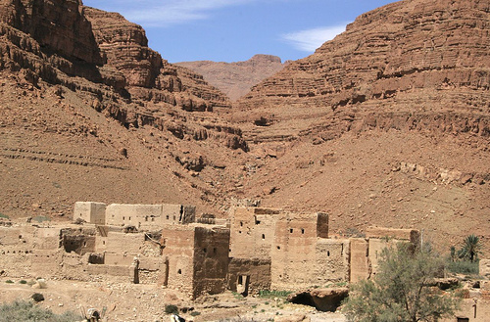 “The capital of Morocco!”

Tuareg Rally. “Things that may or may not be useful to know”

The Tuareg was my first “Rallye” and as an average biker who’s not afraid to admit to making more than a few mistakes I thought I’d do an article on “Things that may or may not be useful to know” as a result. I’m sure many of these points were told to me by experienced bikers before I went but I ignored them so feel free to do the same and learn the hard way – like I did.

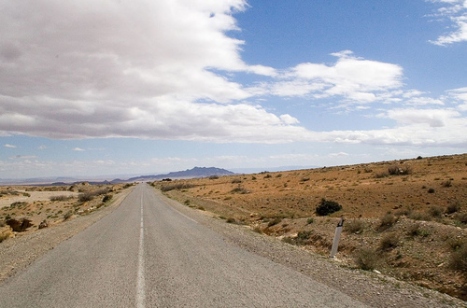
“The (liason) road is long….”

Roadbook.

There are nine daily “roadbooks” . Each book varies in length, the longest being 35 pages, they are A4 length and cut to fit the width of a standard roadbook holder. Well that’s the theory, they are often too wide, so that means every competitor must cut the edge off around 150 sheets of paper. This is a fantastic waste of time so make sure you take some good scissors or better still buy a paper guillotine and impress everyone with your organisational abilities. Don’t rely on the scissors in your first aid kit – from experience it takes ages !

Before pulling the staple out of the supplied road book many people use fluorescent markers to help highlight sections of particular importance. A quick peer around proves that everyone has a different way of doing it, from the minimalist approach (nothing at all) to the highly colourful and apparently complex version (my version). The first version is obvious and seems like a recipe for a slow pootle along the lanes, the second worked extremely well (for me) for the whole rally since it enables the rider to spend less time looking at the roadbook and more time looking at the road.

My system used three colours of highlighter –Pink, Green and Orange .If the road book showed a T-junction ahead, or a sharp turnoff from the main track, colour the route in (green if right , orange if left), also colour in the kilometre box in the same colour. This alerts you well in advance that you might have to stop, watch out for traffic, or that you will get lost if you shoot on past. It also helps remind you which junctions you’ve past when you do blast past so that you can alter the ICO to the correct setting quickly on your return.

If the road book showed a Y shaped junction ahead, colour the route your taking in the corresponding colour. Don’t mark the Kilometre box since you’re just trending one way or the other. A route around an obstacle in the track should also be coloured to remind you to stay left or right of it.

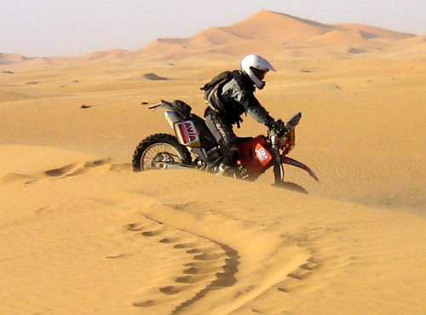 “Dangerous but a lot of fun”

Off-roading is dangerous, and every so often an especially dangerous bit appears, which I coloured in Pink. At first almost everything seemed to be Pink but I quickly found that the roadbook was unreadable during that quick glance down. Instead if there was, for example, a “Groundwave” I just drew a straight Pink line, across the track. Groundwaves vary considerably and need to be taken carefully especially when the suns high and the contrast on the track isn’t too good. When you find yourself doing a handstand on the bars at the same moment as thinking “That’s one of those Groundwaves I heard about !” then you will remember this !

More dangerous still is the dreaded washout, mainly because you rarely ever see roads in Britain that have a six foot deep hole immediately beside, encroaching or even completely crossing the track you’re on. To make it worse they often appear; on the insides of bend that you’re planning to cut across; on the outside of bends that you’ve drifted out of; in the bottom of hidden dips that you missed because of the heat haze; just over that rise that you were jumping over because it looked just the same as the last ten; and in the middle of that apparently flat featureless plain while you fiddled with your GPS. In fact they can appear anywhere so if you can’t see even a smallest part of the track assume it hides the worst. I tended to colour the washout in on the symbol and if it looked awkward (especially if accompanied by a remark such as “hidden behind small hill”) then mark the kilometre box as well.

The reason for marking the kilometre box in colour meant that I could glance down at the number in the box only and immediately know from the colour whether there was a major danger or reason to slow down and take an important turn off the main track I was on. The other coloured in symbols would help in a glance to dictate whether to trend leftwards or rightwards. This way you can easily see if you have miles where the roadbook is only specifying, “follow the main track”. So you can ignore lots of the roadbook– apart from checking every now and again that it does still relate to where you are and what the ICO says. If its not coloured in you can blast on straight ahead. Remember that “straight ahead” on the roadbook still includes bends, obstacles, animals and people so be careful !

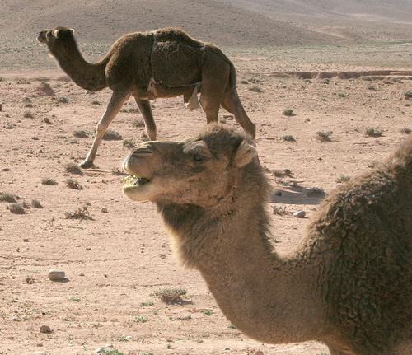 “Waiting around the bend?”

Another point I started to highlight was the GPS waypoints, and in a fit of overkill I’d always write the next GPS point above it. I did this after an early mistake with the GPS in the dunes when I set it to “active route” mode but either the GPS had been edited wrongly or (more likely) I got a bit ahead of myself because I arrived at a Secret check – having missed the previous Timed start –not smart having to backtrack 6km and then return during a timed stage ! I didn’t have this problem again because every night I’d check that the “active route” was in the same order as the road book.

Other info that can appear on the roadbook includes compass bearings – I didn’t pay much attention to these at first – until you get to somewhere with no road and the next waypoint is miles away around some fast approaching hills. Following the GPS arrow rather than the compass bearing generally means you go the wrong way round that huge hill or dune and are completely off route, lost and waiting to have an accident in an unmarked hole on your own. I did this several times before the hole with my name on appeared. I noticed several people had duck taped their manual compass onto the bars as well –probably safer than round your neck on a bit of string and certainly more convenient than in the bottom of your sack like mine was. Until I got into the habit of using them I highlighted them from then on. A final note on pens – bring several of each colour because they “disappear” if you leave them lying about.

With your multicoloured roadbook it is now time to make it into a giant scroll, maybe twenty feet long on some days. This is when bringing several rolls of Magic tape or Sellotape and a good quality dispenser can help earn you some lifelong friends –well at least till the end of the rally. Bumming bits of tape off people every day is yet one more thing that wastes your precious time and reserves of enthusiasm. When I could scrounge enough I’d tape both sides of the paper fully. This is best done when your new buddy isn’t watching you use their supply up ! In my defence I had bought two sticks of Pritt stick –which I left at home !

Once completed it needs fed into the roadbook holder, a neat trick being to leave some paper “tails” (about 6 inches long) on the drive rollers so that you can tape the latest roll in quickly. Its also worth having some sort of tape handy on the trail in case your paper roll splits in half – some ever useful duck tape stuck on the front fender worked for me. Its worth doing a pucker job with the paper rolls because they run more easily if done neatly- its dangerous to ride at speed and be trying to manually wind on the road book because its jamming. This always seems to happen on the rockiest timed section !

Now that I’m happy with my system of marking the roadbooks I’d attempt to do all the boring colouring, cutting and taping on the first day while waiting for the ferry. Doing the roadbook each night was a real distraction from having a blether, and if you’ve got to wait till the morning for tape, scissors or whatever then it makes for more unnecessary stress. This was especially true on the day that I overslept and woke up over an hour later than I intended. Working on it at midnight after doing bike repairs is also not recommended since mistakes tended to creep in and that missed washout might be your last.

ICO

The ICO (or IMO) is basically a trip odometer- but nice and large and easy to read unlike the one supplied on most bikes. Again you need to know how it works and make sure you calibrate it properly. This is easy to do however turn the Auto calibrate function off once you’ve got it set up, otherwise it can recalibrate itself if you get slightly lost. Mine developed an under-reading of one kilometre on a long section and as a result I drove off an unexpected dangerous bend and straight down a 45-degree slope that ended in a sheer drop into a ravine. Luckily I shouted “Pretend it’s Broxburn Bing” and this thought protected me as I managed the luckiest U-turn ever accomplished on a motorbike. Another near fatal mistake was to have the ICO showing the distance to two decimal places (eg 30.59 km rather than 30.5). At speed its hard to ignore the last digit so it becomes more difficult to tie it into what the roadbook says (ie you think it says 30.9 or 35.9). Before you know it you’re confused and one of those washouts is heading for you unexpectedly.
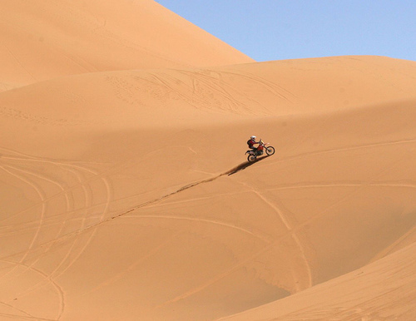
“You need understand GPS !”

GPS

What a fantastic bit of kit a GPS is ! Unfortunately if like me you’ve left it till the last second to buy one on eBay then you probably won’t know how it works. “I’ll find out when I get there !” was my plan. On day two my plan to follow the roadbook was limited by the complexity of the terrain and scarcity of info in the roadbook. The instruction to “head in the direction of the radio-tower” was useless due to the heat haze, dust and confusion caused by a minor crash. . I quickly got lost in the midst of a huge featureless plain and suddenly my casual plan to find out how it worked seemed somewhat naïve and worse still I was on a timed section again! This is where knowing the next GPS point without having to wind the roadbook forward helps ! Heading straight for the next point got me to the end, however the time penalty for working it out “under pressure” probably added four hours of penalty time !

Most GPS have AA batteries as back up but run off the bike battery. Take the AA batteries out and keep them in your pocket. This reduces the weight and stops that expensive Touratech bracket disintegrating itself. I was told this would happen – and it did ! Luckily I’d got a remote antenna attached and this was all that stopped my new GPS disappearing. So cable-tie it onto the bracket as well and don’t forget to remove it each night in case the camels eat it. Another navigation tip is to follow the camel tracks (and pea sized camel poo) – the camels always take the easiest line between two points . The only trouble is you don’t know where they’re heading !

Scorecard & Daily Results

If you can read German then you can skip this bit, it’s probably really obvious when you get there! If not, the scorecard is pretty confusing. By the end of the rally I sort of understood how it all worked and as a result I’m sure I’d do much better if I did it again (even without riding any quicker!).
Every morning you take part in a scrum to show the organiser your safety equipment. They then sign your hand to say you’ve done this and you can pick up your “Bordcarte” or time sheet. Smart competitors avoid this by witnessing the signature/scribble and repeating it themselves on their own hand thus avoiding getting themselves jostled early in the day. I was far too British for that and queued.

The card is similar to an enduro one but warrants more careful reading. Although there are many GPS points only some of these are important for scoring purposes. The main checkpoints are titled DK1, 2, 3, etc and DKZ for the final one. The card will tell you which time is the latest that you can check in, penalty free, and this is useful because it allows you to avoid riding in the dust continuously, get fuel, rest and calm down either before or at the DK. You could even stop for a mint tea, olives and a fish supper if you feel that there’s time to do so.

Understanding this is important because it helps pace the day and means you can be the fastest even at the back of the field. Its ridiculous to get a penalty for being late for non-mechanical reasons and only a complete fool would feel the times were generous enough to, for example, accidentally visit a neighbouring foreign country without the proper paperwork after enjoying a large fish supper. That mistake cost me a place for every chip I ate and it was “a big plate fae !”

Also on the card are the “secret checks”, these are always at GPS points but are obviously not marked as such on the roadbook. You have to find them and get the card signed by an organiser and timed as VDK1,2 or 3. Missing one of these can cost up to six hours in penalties, and is another reason to fully understand how the GPS works.

Slightly confusing is the fact that some GPS points are literally nothing in the middle of nowhere, don’t fret – if it’s a secret check the organiser is usually obvious if not just head for the next one. Make sure that the GPS has engaged the next waypoint first and that it’s the correct one !

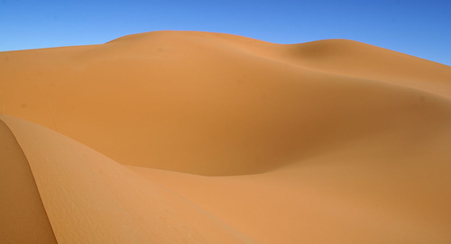
“Nothing in the middle of nowhere “

Since all the specials are of different length they have a weighting factor multiplied into each days result. This seemed to vary all the way up to eight. So one minute extra on the route might add eight minutes to your time ! Get slightly lost and miss just one VDK and your chances of winning are gone !

The big dunes day is where the Tuareg rally is won or lost. There are approximately 5 checks on each of four potential laps. This should ideally take 220 kms - which would be a hard days ride for anybody –especially since it’s difficult to travel in a straight line in the dunes. Inevitable most people ride substantially less than the full circuit and are prevented from passing the important checks if they fail to reach them by a certain time. Each check (at least 20 at the start) that you fail to reach will win you a two hour penalty. So if you fail to reach the first one you can get a forty hour penalty in one day of riding ! Like much of the field I struggled to achieve two whole laps in over six hours although amazingly about ten people did all of it.

If you want a good final position then understanding how the scoring, roadbook and GPS work is far more useful than riding flat out in the wrong direction !

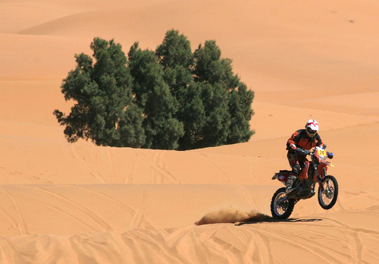
“ Flat oot! “

Riding

You can’t learn to ride a bike by reading a book however if anybody learns anything from this article it should be “Don’t get impatient in the dust”. Morocco is infamous for its dusty rally sections and if there is one thing to kill your enthusiasm for the desert, it’s blind overtaking through the dust of the rider ahead. Due to a terrible start position on Day 2, I had to overtake lots of people in the first 25 kms. All went well until two riders decided to ride side by side for what seemed like ages. This is a pretty poor and selfish technique in my opinion since it makes it extremely hard for other riders to pass. Needless to say I got impatient, took the risk and in nearly zero visibility drove into a washout at 50kph. I managed to fly through the air long enough to think,“That’s me fucked then”, before fortunately landing on my head in my favoured floppy fashion and getting quite concussed. I managed to damage the front rim, bend the sub frame six inches sideways and crush the GPS bracket. When I stood up I found that three litres of water from my burst Camelbak was pouring down my trousers – which made me glad I had got two filled and that it wasn’t blood. The two other riders plodded on, happily oblivious to my cursing.

Worse was still to come when shortly afterwards I saw another biker down an even bigger hole – covered with a space blanket and obviously seriously hurt. Moments like this really challenge your desire to go biking and are perhaps best not dwelled on, other than to learn “It can happen to you”. I don’t know the actual statistic but I wouldn’t be surprised if ten percent of the riders broke some part of themselves and I’m sure most of them fell off hard at some point.

Finally

As you can easily see, there is a lot to be learned on a first rally. The best thing for me was realising that fifteen years of thinking “I could do that” had eventually become “I DID IT !”. The worst was seeing how it could so easily go the other way and be the end of not only your dreams but also those of your family and friends. As a result the whole scoring side of it seemed a bit trivial after that.

Having said that the guy who won this year was apparently in the middle of the field last year, so there’s hope for us all ! See you there next year ?

Reuben Welch

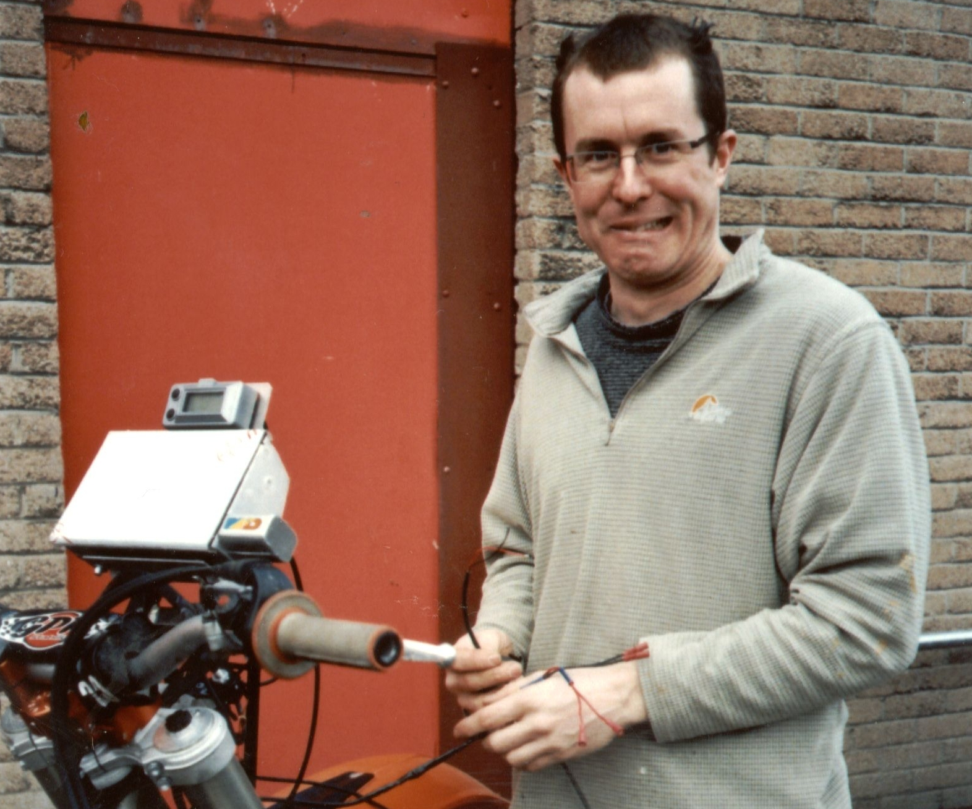
“ Now what was I supposed to do again ???

Photos supplied courtesy of Doug Cain. See some more at http://www.flickr.com/groups/tuareg2006/

