Motorrad Central to Launch New BMW X450 at Metzeler Melville Scottish Enduro
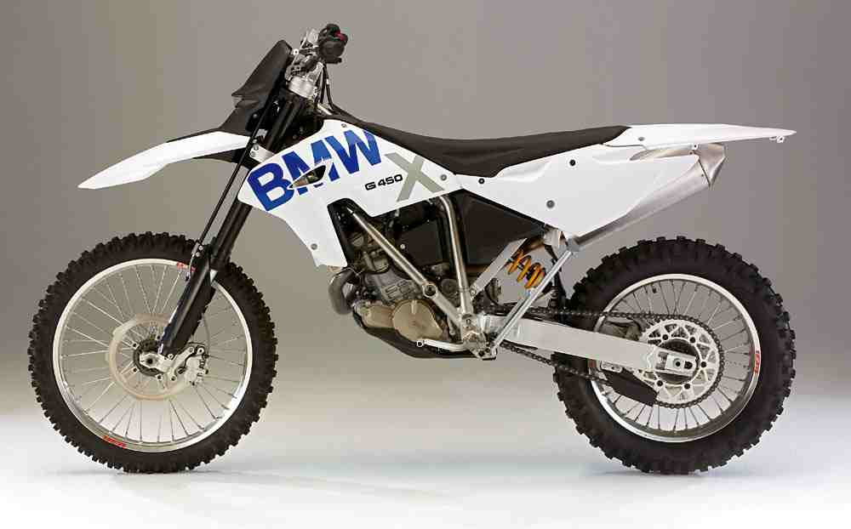

The new BMW G450 X is to have its Central Scotland launch at the Metzeler Melville Motor Club Scottish Enduro Championship on the 21st September.

Motorrad Central who operate BMW Motorrad Dealerships in Dalkeith and Bishopbriggs will display two G450 X bikes at the event being held at Yarrowford Selkirk.

BMW's G450 X is a machine ready to compete the moment it leaves the factory. Unique design and engineering has already drawn world-wide press attention and acclaim. BMW Motorrad Motorsport have already enjoyed notable successes with the G450 X in the WEC, GNCC, and North American competitions.

The Metzeler Melville Motor Club Scottish Enduro is an extremely popular event that caters for experienced and beginner riders. The support and attendance of Motorrad Central is a welcome contribution to the long-term development of Enduro Motorcycling and competition in Scotland.

The event features a special test section which will be located within easy walking distance of the start/parc ferme, allowing spectators to enjoy close-up action as the top Scottish riders compete in this spectacular event.
Details available at www.melvillemc.co.uk www.motorradcentral.com

