31st March 2008

LATEST NEWS

TEAM FRONT ROW COMPLETE PREPARATIONS FOR TUNISIA AND LIBYA

With less than 3 weeks before Front Row GB’s departure for Marseille and the night prologue that will start the Optic 2000, Rally of Tunisia. Both riders, Jon Stamper and Stan Watt carried out their final training on the KTM 690 Rally bikes prior to the bikes being prepared for the first main international desert rally since the cancellation of Dakar ’08.

For the first time, the Rally of Tunisia will incorporate 4 days in Libya before returning to Tunisia for the closing stages of the Rally. The NPO (rally organisors) have put together an exceptional event that will also include an enduro cup category for standard enduro motocycles to experience some of the skills needed to compete in a true international rally.
All Front Row GB riders to also include Derrick Edmondson, will be competing in the main marathon class with the KTM690 Rally Replica, being supported by Walker Ecosse with their MAN T5 6x6 assistance vehicle and technicians, Gordon MacDonald and Scott Gardner.

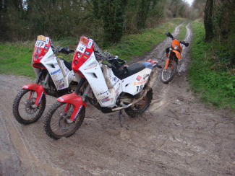
The final training was not orientated around the deserts of North Africa, but to the contrary, torrential rain and gale force wind on the byways and green lanes of southern England. This made for sloppy and more technical riding than normally undertaken on the big KTMs but beneficial nonetheless. The riders spent their final day of training covering 260kms on terrain more accustomed to the trail riders of Dorset and Wiltshire.

As the team put their final planning together for Tunisia and Libya, you will be able to follow the riders and results on the Front Row GB website and at www.npo.fr

