Dear all,

Please find a wee update on my preps for the UAE desert challenge. Suspension is now away to get set up…a first for me… so I’ll be bashing the dunes on my old ktm 250 2 smoke till it comes back.

Early morning roadbook blues….

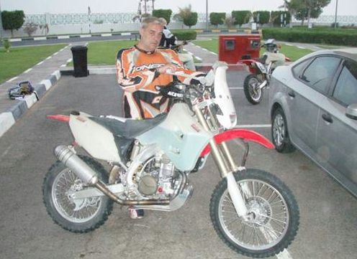

Well then. The main work now been done and I have a bike that is not far away from being ready for the UAE desert challenge. As a bit of preparation, three of us, who are getting ready to do the event for the first time, took a run up to the UAE to get a taste of the kind of terrain we are likely to be riding over. We were accompanied by Youcef and Greasby who are the local desert gurus. Youcef (aka) Paul scored a second place on the recent Tunisian rallye. The drive took about 5 hours so it was quite late when we got bedded down at the side of the road, under the stars.

After about 5 minutes sleep we were getting up to shove some breakfast down our necks, finish our preparations and head off in to the morning traffic to find the start of the days first stage. We had managed to obtain some roadbooks and gps coordinates for some rally stages that might have been used in the past. We filled up before setting off and topped up just prior to finding waypoint 1. Then it was off following the roadbook behind one of the experienced riders. Shortly after I was stopped to be told that if it says you have 4 km to get to the next waypoint then get after it. A bit later the throttle was nailed as I shot past the first turn off. After a bit of reflection it occurred to me that there was a bit more detail in the instruction so we started off again with me taking the lead for the first time. Pretty soon we were flying down a graded track with various landmarks and distances that allowed me to calibrate the ICO. I was having a great time and felt like I was able to keep a reasonable pace.

After about 50 km’s it was my turn to hand over the lead to Dave who was also on his first shot at navigating. Dave’s section took in some dunes and it was soon apparent that the terrain here is a bit special. With sand piles as high as some small Cairngorms we were soon thrashing the nuts off the bikes to get up and over them. As with most forms of off road riding momentum is king until you have too much. The next few hours were spent working that one out and is probably the reason I lost a few pounds this weekend. It’s good to know that the techniques learnt from getting your bike out of mud during enduros work really well in sand. The sand takes less of a hold than some of the goop I’ve been in.

In total we did approx 1200kms over the three days riding with a massive stage being covered on the second day. I got to grips with the new bike in the sand and also feel that I can hold it open a bit more now. The bike also held together quite well.

The event is happening from the 25th October onwards and it should be possible to track my progress live through the iritrack system. The website for the event is www.UAEdesertchallenge.com

If you want any more info about this please feel free to mail me at donaldwrf@hotmail.com

Doon a dune…
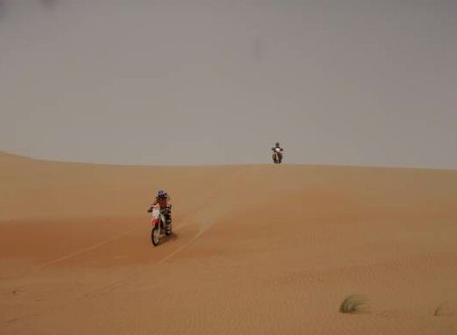

After all that exertion I’m gonna be sick…..

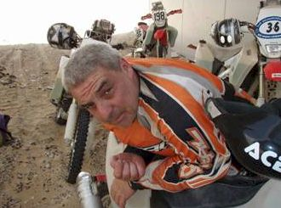

Dave Donald

