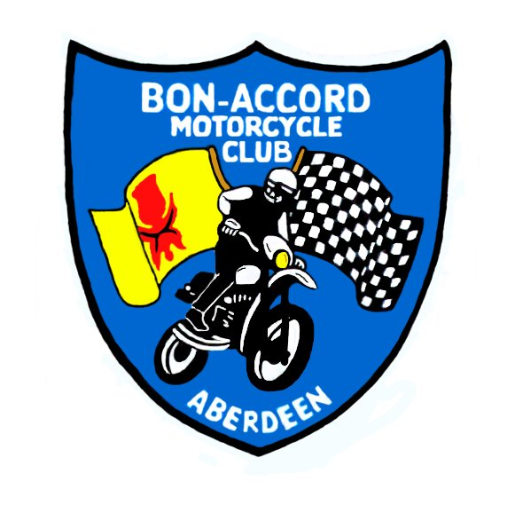

Bon-Accord Motorcycle Club

______________________________________________________________________________

NEWSLETTER

DECEMBER 2002 Issue No. 36 9/12/2002

Dates of Forthcoming Events

Sunday 22nd December 1st Round Club Trial, Whitely Farm, Daviot by Inverurie.
11am start.

Sunday 5th January 2nd Round Club Trial, Colpy Quarry, 8 miles North of
Inverurie. 11am start.

Wednesday 8th January 2003 Club Meeting Bieldside Inn 7.30pm start

Saturday 15th February 2003 Dinner Dance and Award Ceremony, St Leonards Hotel
Stonehaven Featuring the band ESKIMO BLOND

Reports on Previous Events

10th Round Club Trial, Blackburn,17th November

This is a new piece of ground for the club and was organized and laid out by the Clan Barrie. The ground
has lots of potential and more room for expansion, we are sure this can be developed into a cracking event.
The The trial started more than a bit slippery but as the day progressed and the frost lifted the sections settled do down resulting in a good fun event. Results:-

Exp Experts 1st Bill Ross 35 Twin shock 1st Grant Forbes 85
2nd Duncan Mitchell 36
3rd Blair Barrie 47

Non-Experts 1st John Hird 89 S/boy ‘B’ 1st Paul McLachlan 64
2nd Sandy Barrie 125 2nd Duncan Wright 103

Over 40 1st Brian Abel 85
2nd Ken Whittaker 86
3rd Jim Haxton 142 Retiral Graeme Robinson

Novice 1st Murray Whittaker 34
2nd Paul Bursill 74
3rd Roy Murray 81
4th Les Brown 88
5th Keith Watt 93
6th Ian Mitchell 96
7th Bruce Reid 101
8th Frazer Geddes 102
9th Iain McLachlan 109
10th Alan Russel 110
11th Cameron Slater 133
12th Neil Sutherland 140
Annual General Meeting, Stonehaven 26th November

20 members attended this years AGM in the St Leonards Hotel Stonehaven.

The committee posts are as follows-

President Brian Abel one year remaining
Vice President Ken Whittaker one year remaining
Treasurer Di Stuart newly elected
Secretary Di Stuart one year remaining
Trials Convenor John Hird newly elected
Moto-cross Convenor Di Stuart newly elected
Enduro Convenor Dave Donald one year remaining

Committee Members-

2 years Stuart Mackie 1 year Duncan McIntosh
Jim Stuart Billy Ross
Bruce Reid Steve Gammie
Colin Mackie Paul Bursill
Keith Watt Grant Forbes
Janet Whittaker Murray Whittaker
Cameron Slater Archie Barrie

- A proposal presented to the AGM that landowners be offered £3 per rider for trials land use was
carried. This will make it easier to seek out new pieces of ground and retain the ground we have.
- To cover the cost of the above it was agreed that the entry fee for club trials be raised to £10 for
adults but the schoolperson rate will remain at £5.
- The present yellow route in trials is to be given Club Championship status and a Trophy will be awarded to the winner at the end of the year. If a rider, as he or she gets better, wants to do some of the harder route sections they may do so, but if they drop marks it will still be marked as if they were riding to the yellow route. Unlike the other classes a rider may move up to the red/blue route during the season if they feel they can manage. This will of course rule them out of the yellow route championship.

Other Club Matters

* Remember to renew your membership when the reminder comes in or at the next trial
* Remember to renew your Competition License at the end of the year.
* Remember to return all last years Trophies at the next trial and give them to John Hird.
* Club meetings will still be held at the Bieldside Inn until further notice.
* The band for the Dinner Dance is now confirmed as ESKIMO BLOND they are reputed
to be very good so come along and bring your friends. We know the grub is good from
last years doo so all we need is a big crowd of boozers to create an atmosphere.

OBITUARY

It was with sadness that the BAMCC learned of the recent death of Jock Tawse. Jock was given lifelong honorary membership of the Club when he stood down from active participation on the Committee a good number of years ago. He had dedicated a large part of his life to the organisation, promotion and support of motorcycle sport and the support of his son John in motocross and road racing. The death of John whilst road racing in the Isle of Man was a tragedy for Jock and his family but this did not stop Jock's active involvement in the Club. There may not be many Club Members left that still remember Jock, but I do know that Jock maintained a keen interest in the Club and what we were doing through the newsletter and friends. The Club wise to express their sympathies to his wife and family at this sad time and give thanks for Jocks' life and dedication to the Club and motorcycling in general.

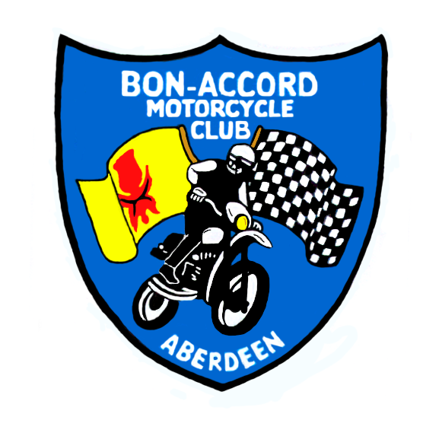 | BON-ACCORD MOTORCYCLE CLUB  AGM 26 November 2002  President’s Report  For the Year  1st November 2001 to 31st October 2002

Welcome to the first AGM of the Bon Accord Motorcycle Club LIMITED.

I am delighted to report on another good year for the Club.

SUMMARY

- A major point of note is that Scotland and the Club are back to normal with a full years sporting calendar now completed following the interruptions of 2001

- A major administrative change has been to Limited Company status on the 13th of March 2002. This has little noticeable effect in the Club’s administration. You will be aware that it was introduced to isolate office bearers and members from possible litigation so hopefully the need will never be realised.

What will hopefully become noticeable is the greater freedom it brings to develop the credibility and ambitions of the Club.

There has been a one off cost of £500 to implement this change. The annual “running” costs are minimal and will be reported on at the next AGM.

- Another major change was from a fixed membership year to rolling membership. Again it will be more appropriate to wait a year before reporting on how this is working as we are only just approaching the roll over time for the first “rolling members”

- There has again been an increase in membership numbers but less marked than in previous years. The executive are developing methods of tracking membership trends so as to be more proactive in responding to membership numbers and interests.

- It is always good to report on a healthy financial position and I can say that this is again the case this year, as will be reported on by our Treasurer.

- I have had several reports that the Club is well regarded in Scotland by other Scottish Clubs and the SACU. This can be attributed to the positive attitude and ambition of the executive, the convenors and the membership as a whole. The Club’s attitude prior to and through the troubles of 2001 has undoubtedly been carried through this year.

Well done to everyone

MEMBERSHIP

 | 31/10/2002  see below | 2000/2001 | 1999/2000
Adult riders | 110 | 97 | 78
Schoolperson riders | 6 | 14 | 10
Non-riders | 8 | 9 | 7
TOTAL | 124 | 120 | 95

Interest

Trials | 90 | 82
Enduro | 32 | 36
Motocross & Quads | 32 | 10
Road Race | 14 | 2
Total | 136 | 130

The SACU charge a per-capita fee calculated from Club membership numbers in a year. This has been based on numbers at the end of October and per last years AGM this will continue to be the case.

This also permits the AGM reporting basis, as tabulated above, to continue as a “31 October snap shot” of membership numbers, types, interests and trends.

Membership is up 5% on last year compared with a 26% increase the previous year. I don’t think that this is because we have reached a plateau. It could be due that Club promotion is slightly down on last year – See below

There is a good increase in the number of Adult riders (13%) but a sad decrease in Schoolperson riders (57%)

It would seem that all recreation and sports have suffered a little from the foot and mouth effects in 2001. This year it seemed that riders were less motivated to organise their entries for the calendar events. Convenors, not only in our Club, found that they had to chase people for entries more than usual. It may be that some riders have been lost to other interests; family, home improvements etc.

A substantial effort was put into bringing motocross back onboard. This was expected to swell the numbers but as they say “the best laid plans…”. More on this later.

2002 PROMOTION

The amount of active promotion was slightly down on last year.

- Laminated posters and membership forms were posted on the notice boards of most local bike shops – as last year
- The box trailer with its professional signage is present at all Club events – mainly just the Nationals last year
- Again good numbers joined to get rides in the Enduro
- There was no Indoor Arena Trial due to building work at the AECC
- The Club again did an arena trial demonstration at the Elgin Motorcycle Show
- The trailer and merchandise sales was at the Alford motorcycle convention in September after a long absence
- The Club has a contact listing in the P&J motoring supplement most Wednesdays – as last year

I have had the usual number of calls from people interested in getting involved with our sports and the Club with contact mainly coming through the Bike shops. At Elgin and Alford most enquiries were to do with motocross and quad facilities.

The corner stone of Club communication is the Newsletter and Ken Whittaker has kept this going through another year. Some go out as emails and at the same time Di Stuart does a mailing to the balance. This should be simple, but apparently, Ken has to sort out a few undelivered ones every time, because people change their addresses or stop paying their server subscriptions etc. When this happens, Ken has to get Di to do a special mailing.

Procurement of Dedicated Land

There is always a discussion on some aspect of land availability whether it is procurement or just the regular search for new venues.

The main drive on this front, beyond the norm, is that the Executive have started to formulate a “Business Plan” to identify the actions of how best to achieve this. A Business Plan is seen as the best way of communicating our needs those that may be able to help us. As will all communication it is important that the Club is seen to have a unified voice and again a Business Plan should get us all singing the same tune.

Some very interesting ideas are coming out and hopefully it should not be too long before a “Plan” can be presented to the wider membership for comment and information.

TRIALS

National 1 x Adult, 2 x National Restricted
Club 10 round Club Championship (through to 17 November)
Arena 1 x Elgin Motorcycle Show, 1 x Steam Engine Rally cancelled
Fun 1 at Elgin the day before the MCC Show

Trials continues to be the mainstay of the Club and, due to the changes in insurance premiums, has been the biggest earner for the Club this year.

Colin MacKie as Trials convenor organised all Club and National rounds but, by his own admission, has set out very few trials this year.

What Colin has done very successfully is delegate this aspect of the job to the extent that we now have a good number of Members confidant in finding and setting out sections.

There was more than the normal amount of criticism as to the difficulty of some trials. Negative criticism is not welcomed, especially when in most if not all cases the circumstances were beyond the Club’s control. The weather was against us on many more occasions than I want to remember. For example, Peter Culter was set out in dry weather conditions on two occasions, only to be made very difficult by overnight rain and flood conditions. On one occasion, new sections had to be set out on the Sunday of the trial because the river ones had disappeared. Rain had the same effect on other Club trials and the last National Trail.

The Club has now hosted an Adult National in two successive years with good success.

Peter Culter was a new venue developed this year thanks in the main the Paul Bursill, Richard Milne and their several helpers.

An attempt to use a new venue at Bucksburn was scuppered earlier in the year thanks to an objectionable, sorry objecting neighbour. Thanks to the Barries for uping sticks to Colpy on a Saturday for the event to go ahead the next day.

Thanks again to the Barries and helpers for introducing and marking out another new venue at Bucksburn this month.

Archie stood down last year from the position of Arena Trial Convenor, but this did not stop him organising two events in the year. The first was for the Steam engine Rally which was unfortunately cancelled a week before the event due to waterlogged state of the ground. The second was at the Elgin Motorcycle Show. This event was very successful and benefited from having good weather. Tied in with this event was a fun trial at the Elgin motocross track ground. Thanks to John Miller for setting this out.

There remains an action on the executive to improve the “observing skills” of riders and free observers. Perhaps a training manual could be developed as something that would benefit the sport as a whole ? We have the technology – all we need are the film stars. This may also benefit the Club in getting observers for Nationals.

Club events, have been erratic their incorporation of a yellow route for beginners. It is hard to justify the marking out of a yellow route when it is unknown as to whether or not it will be used. In addition, and when pressed for time, it tends to be the yellow route that is sacrificed. This is an area for further discussion by the executive.

A big thank you to Colin, Stuart and Craig for all their efforts over the last two years. Much of Colin’s hard work will ease the transition to a new convenor and be a legacy for a considerable time to come. In managing to delegating the marking out of trails Colin has increased the number of members with the confidence to do this task.

ENDURO

The National Enduro this year was held at the same venue as last year, this time at the end of July. The following report is an extract from the Scottish Enduros web page.

Another superb event by Dave Donald, fresh from his finish in the Scottish Six Days Trial. He obviously thought that last year was a bit lenient and decided to toughen up the competitors this year. Quote from his riders meeting prior to the race " A tour round the roads with some off road stuff to keep you happy". Fair enough, there were a couple of nice road/ trail sections but there were also some great pure enduro rides, in all there was over 5 hours of racing - that has to be the best value entry fee this year. A lot of riders stayed clean on time so the lap times were spot on. The test was straight from the World Rounds with a taped section in a quarry over rocks with some tricky turns then a fast blast to the timing chicane.

A bit hard for some of the sportsmen but most managed at least one lap. Due to lack of time and Dave’s dislocated shoulder there was not enough time to set out Sportsmen loops - but there should be some by next year.

As last year, the organisation and running of the event was praised by the SACU Stewards and riders. It was a much tougher challenge, for the experts especially, with quite a few retrials overall but no injuries. Obviously, physical and bike fitness was a problem for most.

Thanks to Dave Donald, helpers, family and friends especially so in consideration of the injury he sustained at the Loch Lomond two day trial 4 weeks before the event.

MOTOCROSS
The year started off well with the possibility of a track being developed at Gourdon, south of Inverbervie.
A frank and open meeting with the landowner to discuss technical and financial arrangements meant that all parties saw that financially it could be made to work, however, all parties felt it prudent to break in the ground first.
This was done with the organisation of a “try the sport day”. The number of motocross and quad riders who turned up was sufficient for the Club to doubt the suitability of the ground for competition. As this was the Club’s main interest, as opposed to practice, it was decided to pull out from expending any more effort and expense. As it transpired, the Club made a small amount of money on the “try the sport day” and was refunded the full amount for posts that were purchased.
Rather than put the executive off motocross, the experience has been taken as a lesson learned. The Executive is still proactively investigating land options for motocross / quads.

Club Assets

Ifor Williams box trailer. Price New £2467.50

There is a host of Arena Trial hardware at the AECC but the bulk of it is being cleared to the bonfire and scrap, except for the waterfall and big steel pipes, which are the property of Whittaker Engineering. The AECC say that they are happy to store these.

Enduro bits and pieces include, market posts, a laptop, staplers, loppers, saws, marker flags, stop watches (2)
- The stock of trials markers and punches are in need of topping up. New punch cards were purchased this year.
- We have quite a few sew on badges but only a few sweatshirts left.
- The stick on car badges are to be sent out with new membership cards until used up.
- There is a box of old trophies

As a rough estimate I would say the Club has an asset value of £1700 - £2000

THE YEAR AHEAD

The year ahead should look to maintain and develop the involvement of members beyond the normal office bearers in the pursuit of land options and with helping set out of trials.
Trails observing skills and standards should be proactively developed. The executive could consider this as an action for a sub committee.
The Business Plan is to be developed and its implementation got underway.

THANK YOU

- To Di Stuart, Ken Whittaker and Richard Milne. To Di for here role as Club Secretary and her support in implementing rolling membership. To Ken for his work on maintaining and developing the newsletter and his general good guidance. To Richard Milne in his role as treasurer and to Di, Ken, and Janet Whittaker for assisting with the accounts and Treasurer's Report given Richy’s recent change of circumstances.
- To all our very hard working convenors and their helpers
- To all committee members, especially to those who are standing down this year
- To all those who present themselves for election for the coming year or two years
- To the Beildside Inn and staff who have hosted our monthly meetings and look after us so well through the year

And finally, thank you the membership and friends for coming tonight and supporting the BAMCC Limited

Brian Abel 25/11/02

Letter from John Hird the new Trials Convenor-

I’m pleased to inform you that I have been voted on as trials convenor for 2003,2004. I am more than a little apprehensive about the living up to the reputation of out going convenor Colin Mackie. Colin has done a great job for the past two years and I only hope to be able to continue his good work.
Although I will try and take a lead in setting up a good variety of trials in the coming year I will no doubt need your assistance with the actual laying out of sections. Please let me know if you can assist with this task throughout the year.

Following a decision made at the AGM we have increased the trials fee to £10 for adult rider and £5 for a school person. The reason for this is to allow a £3 per entry payment to be made to land owners. We believe that this will improve our standing with these important people and smooth the way for the opening up of new ground. This change opens up the possibility of returning to land unused for many years that will greatly improve variety. I hope to use the following land this year.

Colpy, Newmacher, Stonehaven, Findon, Daviot, Burnhervie, Peterculter, Nigg, Lumsden & Blackburn.
Confirmed Dates:

22nd December – Round One of the club championship – Whitely Farm, Daviot by Inverurie. Starts 11am sharp.

The route will be sign posted from the A96, north Inverurie Roundabout.
Leave A96 to the right at north Inverurie (safeway) roundabout (you are entering Inverurie)
100 Metres – Take second left at roundabout on to Burghmuir Drive
1Km – Go straight across roundabout following signs for Rothienorman. (You are now leaving Inverurie)
6Km – Pass Daviot on right, stay on main road past Daviot turn off.
1Km – Whilely Farm is on your left.

5th January 2003 – Round Two of the club championship – Colpy Quarry, 8 miles north of Inverurie Starts 11am sharp.

See you all soon.
John Hird – The convenient convenor

Letter from Keith Watt, a new committee member-

Road Race News

I have just completed what is definitely my most exciting seasons racing to date in the MRO Supersport 600 National Championship. The class is normally referred to as the axe-murderer class, and it lived up to its name this year for me. I was punted off the track on the last lap at Snetterton, crossed the finish line at Brands leaning on another bike, clashed again with a rider at Oulton on the last lap, before being taken out again myself on the first lap at Silverstone. And these ‘incident’ all involved the same guy, you should see the rest of them…
I finished 14th overall in the championship, with a best finish of 8th at Snetterton (was in 6th right up to the last corner on the last lap where, yes you guessed it…).
My ambition for the winter is to complete a trial without appearing foolish – and it seems I still have some way to go after the last one at Blackburn.
On the Scottish racing front, things are not looking too good for next year. Knockhill and Mallory Park were both left off the provisional fixtures list. Mallory was left out due to safety concerns (a lack of run-off at the Esses), but I do not know the reasons behind Knockhill’s omission. The latest news is that Mallory have committed to making the required changes to the circuit (slower entry into the Esses, with more room before hitting the tyre wall), and the circuit owner’s claim that a date has now been provisionally agreed. This cannot be good news for Knockhill, as all the allocated meeting dates are now taken – one rumour is that Knockhill may organise a ‘Scottish Superprix’. I will keep you posted on the latest news in the ‘English Superbike Championship’ as the story unfolds.

Keith Watt.

