BON-ACCORD MOTOR CYCLE CLUB  MEMBERSHIP APPLICATION FORM | 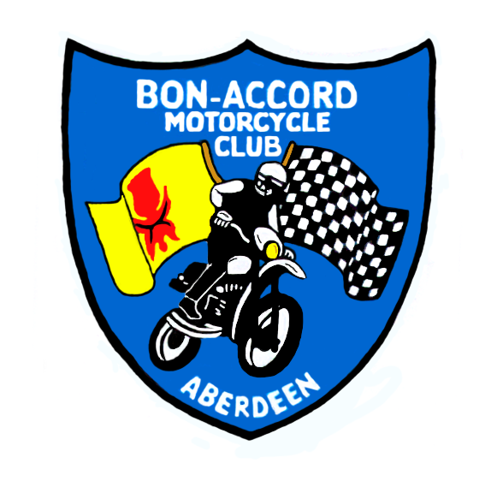
Annual Membership fees.
Official use only;
Expiry date;

Adult Riders £ 15.00

Schoolperson £ 12.00
Non Rider £ 10.00

I am interested in MOTOCROSS / TRIALS / ENDUROS / ROAD RACING / QUADS
(delete as appropriate)

I require licence forms for MOTOCROSS / TRIALS / ENDUROS / ROAD RACING / QUADS (delete as appropriate)

Name (Block Capitals Please) .....................................................................................
Address...............................................................................................................................................................................................................................................................
Post Code..............................................Tel.No.............................................................
Signed....................................................email……………………………………………
Enclosed Cheque / Cash for £.........................
(please make cheques payable to the “Bon-Accord Motor Cycle Club”)

When completed please send with FEE and a SELF ADDRESSED ENVELOPE
to: Diane Stuart, 3 Woodview Place, Stonehaven, AB3 2GD. Tel; 01569 763025
……………………………………………………………………………………………………………………………….

NOTES – BAMCC Membership Application

- Membership is for 12 months starting in the month of application and ending 12 whole months afterwards. Renewal notices will be sent out in advance of the renewal.
- Please read and retain the Bon-Accord Motor Cycle Club (BAMCC) Rules and By-Laws as attached.
- An application for membership is a declaration that you accept the Rules and By-Laws and will abide by Committee decisions.
- The Bon-Accord Motor Cycle Club (BAMCC) reserves the right to refuse any application for membership.
- An applicant that is refused membership will be advised and their fee returned as soon as possible.
- All members are welcome to attend Committee meetings.
- Committee meetings are scheduled for the first Wednesday of the month, 7.30pm at the Beildside Inn, Aberdeen, unless advised otherwise.
- As a member you will receive regular newsletters advising event dates and locations; recent event results and rider standings in club championships; updates on the Club business and general points of interest. The newsletter also offers the facility to freely advertise private Sales and Wants and competitive rates for Commercial advertising.

